Biasetti et al. Elevated amyloid beta disrupts the nanoscale organization and function of synaptic vesicle pools in hippocampal neurons.

Rationale for iGluSnFR experiment with pre-stimulation.
The aim of the experimental protocol (repeated bouts of 5 s stimulation at 2 Hz, and 5 s rest) was to put neurons under an activity load that was broadly compatible with strong physiological firing rates and where the capacity for sustained signalling would thus likely depend, at least in part, on the efficiency of vesicle recycling pathways. In this way we could explore how the presence of Aβ42 might impact these processes and influence transmission capacity. For this reason, the iGluSnFR experiments in the paper (Figure 5) all used this pre-stimulation protocol. It is possible, however, that even in the absence of pre-stimulation, Aβ-related deficits on transmission would be observable, for example reflecting the cumulative effects of prior activity in the network. This was tested in a few pilot experiments that were run alongside the pre-stimulation experiments and are summarized in the supporting figure below. As expected, initial response amplitudes in this non pre-stimulation condition were higher in both control and Aβ42-treated samples, consistent with the idea that imposed prior stimulation will inevitably impact on transmission. Analogous to the pre-stimulation protocol experiments, there was also a maintained reduction in response amplitude in Aβ42-treated synapses relative to matched controls, supporting our observation that Aβ impacts ongoing signalling capacity. This supports the idea - raised in the Discussion - that Aβ42 treatment might serve to uncouple vesicle turnover from glutamate filling/release, something deserving further investigation in future work.

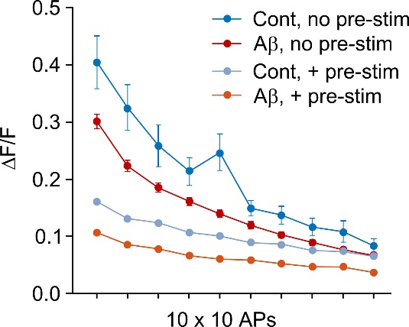

Supporting Figure. Glutamate signalling with and without pre-stimulation. Plot shows amplitudes for iGluSnFR responses to 10 x 10 AP stimulation for control and 1 μM 4-5 d Aβ42-treated synapses. In the ‘+ pre-stim’ condition (cont, n = 845 synapses; Aβ, n = 570 synapses) cultured neurons received a 5 min stimulation protocol consisting of repeated bouts of 5 s stimulation at 2 Hz with and 5 s rest (see also Fig. 5 in manuscript). The ‘no pre-stim’ groups (cont, n = 23 synapses; Aβ, n = 48 synapses) did not receive this protocol.

