Biasetti et al. Elevated amyloid beta disrupts the nanoscale organization and function of synaptic vesicle pools in hippocampal neurons.

Rationale for timecourse and concentration of experiments
Optimization of the vesicle recycling measurements was performed with different concentrations and timeframes of incubation. 4-5 days was found to reveal robust effects of 1 µM abeta on vesicle reuptake, while an earlier timepoint did not (Supporting Figure panel (a), below). This longer timeframe of incubation also permits comparisons with our ex vivo EM data where brain tissue was taken from animals exposed to Aβ42 from birth. A challenge with readout of synaptic function after short-term treatment is that it is likely to include periods of adaptive change in which synapses homeostatically adjust to alterations in signalling or neuronal activity associated with the addition of the toxic peptide, and so would confound interpretation of the data. In comparison, a longer-term treatment reflects the persistent state of increased Aβ42 load and thus gives us the opportunity to study the steady-state responses – arguably more indicative of pathological states. In our system, we see significant levels of cell death after 7 days incubation at 10 µM which we have previously characterized extensively (Marshall et al., 2020, CMLS, 77:5031-5043). At 1 µM, cell death occurs at a similar level to buffer alone (background) at 3 and 7 days (Supporting Figure panel (b), below). As such we think this is the ‘sweet-spot’ where synaptic dysfunctional effects emerge but are not accompanied by cell death.

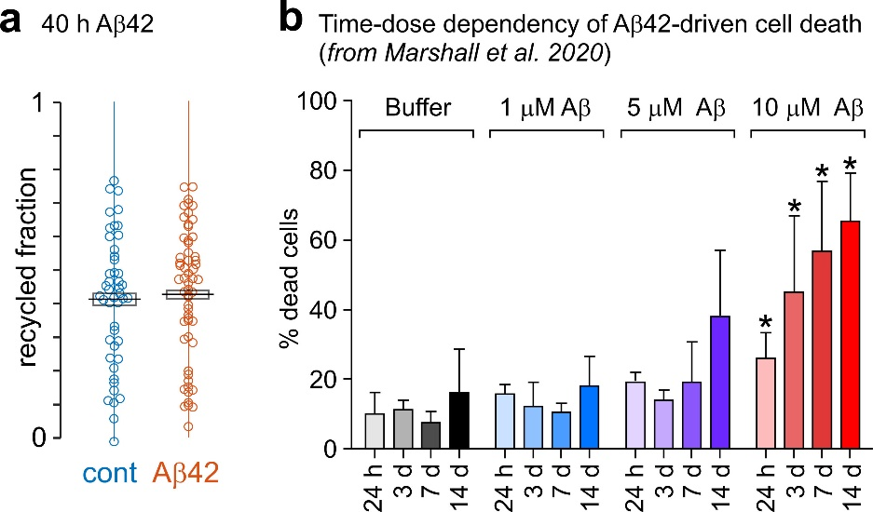

Supporting Figure. Time and concentration dependent effects of Aβ42. (a) Recycled vesicle fraction with control (n = 46 synapses) or 1 μM Aβ42 (n = 58 synapses) incubation for 40 hours (t-test, P = 0.56, not significant). (b) Aβ42 oligomers cause death of primary neurons in a time and concentration-dependent manner. Cells were incubated either with buffer or Aβ42 oligomers. Assessment of oligomer toxicity used a Readyprobes cell viability assay. Data shown are averages from three FOV (fields of view) in at least three experiments ± SEM (standard error of mean). Unpaired student’s t-test; significant differences versus buffer are indicated by * (p < 0.05). From Marshall et al., 2020, CMLS, 77:5031-5043.

