The role of novel genes rrp1+ and rrp2+ in the repair of DNA damage in Schizosaccharomyces pombe.
Dorota Dziadkowiec^{1*}, Edyta Petters¹, Agnieszka Dyjankiewicz¹, Paweł Karpiński^{1§}, Valerie Garcia², Adam Watson² and Antony M. Carr²

¹ Faculty of Biotechnology, Wrocław University, Przybyszewskiego 63-77,
51-148 Wrocław, Poland
² Genome Damage and Stability Centre, University of Sussex, Falmer, Brighton, BN1 9RQ, UK

Keywords: Homologous recombination; Replication-associated DNA damage; Double-strand break repair; HR-mediator proteins

* corresponding author: phone: +4871 375 6238 fax: +4871 375 6234
e-mail: dorota@biotrans.uni.wroc.pl
§ present address: Department of Genetics, Wrocław Medical University, Wrocław, Poland
Abstract
We identified two predicted proteins in Schizosaccharomyces pombe, Rrp1 (SPAC17A2.12) and Rrp2 (SPBC23E6.02) that share 34% and 36% similarity to Saccharomyces cerevisiae Ris1p, respectively. Ris1p is a DNA-dependent ATP-ase involved in gene silencing and DNA repair. Rrp1 and Rrp2 also share similarity with S. cerevisiae Rad5 and S. pombe Rad8, containing SNF2-N, RING finger and Helicase-C domains. To investigate the function of the Rrp proteins, we studied the DNA damage sensitivities and genetic interactions of null mutants with known DNA repair mutants. Single Δrrp1 and Δrrp2 mutants were not sensitive to CPT, 4NQO, CDPP, MMS, HU, UV or IR. The double mutants Δrrp1 Δrhp51 and Δrrp2 Δrhp51 plus the triple Δrrp1 Δrrp2 Δrhp51 mutant did not display significant additional sensitivity. However, the double mutants Δrrp1Δrhp57 and Δrrp2 Δrhp57 were significantly more sensitive to MMS, CPT, HU and IR than the Δrhp57 single mutant. The checkpoint response in these strains was functional. In S. pombe, Rhp55/57 acts in parallel with a second mediator complex, Swi5/Sfr1, to facilitate Rhp51-dependent DNA repair. Δrrp1 Δsfr1 and Δrrp2 Δsfr1 double mutants did not show significant additional sensitivity, suggesting a function for Rrp proteins in the Swi5/Sfr1 pathway of DSB repair. Consistent with this, Δrrp1 Δrhp57 and Δrrp2 Δrhp57 mutants, but not Δrrp1 Δsfr1 or Δrrp2 Δsfr1 double mutants, exhibited slow growth and aberrations in cell and nuclear morphology that are typical of Δrhp51.
1. Introduction
In all organisms studied to date, including Schizosaccharomyces pombe [1], homologous recombination (HR) is essential for normal DNA replication, the repair of DNA double strand breaks (DSBs) and underpins genetic diversity. Mechanistically, HR has been described as proceeding in three steps. In the first (pre-synaptic) step, DSB recognition and the 5’ - 3’ strand resection of the DSB end occurs. In the second (synaptic) step, an invasive 3’ single-strand DNA (ssDNA) tail searches for DNA sequence homology. The key protein required for the homology search and for subsequent duplex invasion is highly conserved from bacteria to mammals. In bacteria this is the RecA protein, which coats the ssDNA tail forming a nucleoprotein filament that is essential for the homology search, the DNA duplex invasion and the subsequent strand exchange. Following strand exchange, a D-loop is formed and a DNA polymerase extends the 3’ end of the invading strand. In eukaryotes, a single RecA homolog performs the same function and is known as Rad51 (Saccharomyces cerevisiae and mammals) or Rhp51 (S. pombe) [2].
The 3’ ssDNA tail generated by nuclease resection of the initial DSB during the pre-synaptic step of HR is immediately coated with, and stabilized by, the heterotrimeric replication protein A (RPA) [3]. Thus, the Rad51 (or Rhp51) recombinase needs assistance from other proteins to overcome RPA’s high affinity for ssDNA. Such factors are referred to as "recombination mediators". The first mediator identified was the S. cerevisiae Rad52 protein, which localises to the 3’ ends of ssDNA and is required for the removal of RPA and its exchange for Rad51 [4, 5]. While Rad52 is required for all recombination events in both the S. cerevisiae and S. pombe model eukaryotes [6, 7], additional proteins or complexes are necessary for Rad52 to facilitate the formation of the Rad51 nucleoprotein filament. In the fission yeast S. pombe, two such functions have recently been defined by both genetic and biochemical experiments: the first function, provided by the Rhp55/Rhp57 complex, is largely inferred from our knowledge of the homologous proteins (Rad55/Rad57) characterised in the budding yeast S. cerevisiae [8]. By analogy, Rhp55/Rhp57 stabilise the Rhp51 nucleofilament and enhance Rhp51-mediated strand exchange [9, 10]. The second mediator function in S. pombe is provided by the Sfr1/Swi5 complex [11]. Genetic analysis suggested that Sfr1/Swi5 acts as a mediator in parallel to, but independent from, Rhp55/Rhp57 during Rhp51-mediated strand exchange [12]. Interestingly, Swi5 forms a separate complex with an Sfr1-like protein, Swi2, which shares homology with S. cerevisiae Mei5. Together with Rhp51, the Swi2/Swi5 complex is specifically involved in the HR-dependent process of mating-type switching [11, 13, 14].
In the third (post-synaptic) step, DNA synthesis is initiated and the invading strand is extended. Subsequently the extended invading strand is displaced to facilitate synthesis-dependent strand annealing (SDSA) or it is not displaced but ligated to the free 5’ termini following capture of the second DSB end, resulting in the formation of Holliday Junction (HJ) intermediate(s) which are subsequently resolved into crossover (CO) or non-CO recombinant products [7, 15]. Using an HO endonuclease-induced DSB assay [16], evidence was presented that suggested recombination outcomes may be dependent on the initial choice of a mediator pathway: specifically, Rhp55/Rhp57, but not Swi5/Sfr1, were shown to be essential for CO production [17, 18]. Although these results were not confirmed in a separate study [19], functional differences among various Rhp51 mediators are likely to underpin the mechanism and outcomes of recombination and will doubtless be the subject to future investigations.
HR is particularly important during DNA replication, enabling the bypass of unrepaired lesions that would otherwise act as replication fork barriers, and in promoting the restart of replication forks if barriers are encountered [20, 21, 22]. Thus, Δrhp51 and Δrad22 mutants are not only sensitive to DNA-damaging agents that generate DSBs directly, but also to a range of agents that cause ssDNA lesions which can potentially block the replicative polymerase. Since such lesions also occur spontaneously at a low level, recombination defective mutants such as Δrhp51 and Δrad22 (the S. pombe homolog of Rad52) show a slow growth phenotype and constitutive checkpoint activation resulting in cell cycle delay. Because ssDNA is a common intermediate of many aspects of DNA metabolism, the action of Rhp51 and thus of its mediators must be tightly controlled to avoid deleterious recombination occurring via the inappropriate activation of HR-dependent DNA damage tolerance pathways or DSB repair. In part, this function is fulfilled by anti-recombinogenic helicases such as Rqh1 [22, 23], Srs2 [24, 25] and Fbh1 [26, 27], all of which have been previously described in S. pombe.
Understanding the regulation of the pro-recombinogenic mediators and anti-recombinogenic helicases, plus the identification of new factors involved in these processes, will be essential in building the model of how HR is regulated in mitotic cells. An inability to regulate HR correctly is predicted to cause the formation of unwanted crossovers and gene conversion events that can lead to loss of heterozygocity or chromosomal rearrangements. Here we report the analysis of two novel DNA repair proteins, Rrp1 and Rrp2, from S. pombe which are involved in HR. On the basis of their domain structure, the Rrp proteins are predicted to have roles in DNA remodelling and DNA repair. We show that Rrp1 and Rrp2 participate in the Sfr1 sub-pathway of DSB repair and are involved in replication-dependent DNA damage tolerance by homologous recombination.

2. Materials and methods:
Strains and plasmids
Strains used in this work [Table 1] are derived from the parental strain YA 254.
TABLE 1. Strains used in this study.
Strain | genotype | Ref.
YA254 (WT) | ura4-D18, leu1-32, his3-D1, arg3-D1, h90 | 11
Δrhp57 | rhp57D::his3+, ura4-D18, leu1-32, his3-D1, arg3-D1, smt0 | 10, 11
Δrhp51 | rhp51D::his3+, ura4-D18, leu1-32, his3-D1, arg3-D1, smt0 | 11
Δsfr1 | sfr1D::ura4+, ura4-D18, leu1-32, his3-D1, arg3-D1, h90 | 11
Δrrp2 | rrp2D:kanMX6, ura4-D18, leu1-32, his3-D1, arg3-D1, h90 | a
Δrrp2 | rrp2D::natMX6, ade6-704, ura4-D18, leu1-32, his3-D1, arg3-D1, h90 | a
Δrrp1Δrrp2 | rrp1D::kanMX6, rrp2D::natMX6, arg3-D4, leu1-32, his3-D1, ura4-D18, h90 | a
Δrrp1 | rrp1D:kanMX6, ura4-D18, leu1-32, his3-D1, arg3-D1, h90 | a
Δsfr1Δrhp57 | sfr1D::ura4+, rhp57D::his3+, ura4-D18, leu1-32, his3-D1, arg3-D1, smt0 | a
Δrrp1Δrhp51 | rrp1D:kanMX6, rhp51D::his3+, ura4-D18, leu1-32, his3-D1, arg3-D1, smt0 | a
Δrrp2Δrhp51 | rrp2D:kanMX6, rhp51D::his3+, ura4-D18, leu1-32, his3-D1, arg3-D1, smt0 | a
Δrrp1Δrhp57 | rrp1D:kanMX6, rhp57D::his3+, ura4-D18, leu1-32, his3-D1, arg3-D1, smt0 | a
Δrrp2Δrhp57 | rrp2D:kanMX6, rhp57D::his3+, ura4-D18, leu1-32, his3-D1, arg3-D1, smt0 | a
Δrrp1Δsfr1 | sfr1D::ura4+, rrp1D:kanMX6, ura4-D18, leu1-32, his3-D1, arg3-D1, h90 | a
Δrrp2Δsfr1 | sfr1D::ura4+, rrp2D:kanMX6, ura4-D18, leu1-32, his3-D1, arg3-D1, h90 | a
Δrrp1Δrrp2Δrhp51 | rrp1D::kanMX6, rrp2::natMX6, rhp51D::his3+, arg3-D4, leu1-32, his3-D1, ura4-D18, smt0 | a
Δrrp1Δrrp2Δrhp57 | rrp1D::kanMX6, rrp2D::natMX6, rhp57D::his3+, arg3-D4, leu1-32, his3-D1, ura4-D18, smt0 | a
Δrrp1Δrrp2Δsfr1 | rrp1D::kanMX6, rrp2D::natMX6, sfr1D::ura4+, arg3-D4, leu1-32, his3-D1, ura4-D18, smt0 | a
Δrrp1Δrhp57Δsfr1 | rrp1D::kanMX6, rhp57D::his3+, sfr1D::ura4+, arg3-D4, leu1-32, his3-D1, ura4-D18, smt0 | a
Δrrp2Δrhp57Δsfr1 | rrp2D::natMX6, rhp57D::his3+,sfr1D::ura4+, arg3-D4, leu1-32, his3-D1, ura4-D18, smt0 | a
chk1-HA (WT) | ura4-D18, leu1-32, ade6-704, chk1:HA, h+ | a
chk1-HA Δrhp57 | rhp57D::his3+, ura4-D18, leu1-32, his3-D1, chk1:HA, h+ | a
chk1-HA Δrhp57Δrrp1 | rhp57D::his3+, rrp1D::kanMX6, ura4-D18, leu1-32, his3-D1, chk1:HA, h+ | a
chk1-HA Δrhp57Δrrp2 | rhp57D::his3+, rrp2D::kanMX6, ura4-D18, leu1-32, his3-D1, chk1:HA, h+ | a
chk1-HA Δrrp1Δrrp2 | rrp1D::kanMX6, rrp2D::natMX6, ura4-D18, leu1-32, his3-D1, chk1:HA, h+ | a
KAF1448 | Rad22-GFP::KANMX6, leu1-32, ura4-D18, h+ | b
a - this work; b - rad22-GFP was a gift from Miguel Ferreira,
The entire reading frames of the rrp1⁺ and rrp2⁺ genes were replaced by kanMX6 and/or natMX6 markers using a one-step gene disruption method [28]. Stable transformants were screened by PCR and verified by Southern blot analyses. Tdimer2 was amplified by PCR on pKT178 plasmid [29] adding NdeI and SalI restriction sites respectively and cloned into pREP41, giving pREP41-tdimer2 plasmid. The rrp1⁺ gene was PCR amplified using genomic DNA as a template and cloned into the NdeI-SmaI sites of pREP41-EGFPN [30], or into SalI -SmaI sites of pREP41-tdimer2 plasmid. Both inserts were verified by sequencing.
Media and general methods
Media used for S. pombe growth were as described [31]. Yeast cells were cultured at 30ºC in complete yeast extract plus supplements (YES) medium or Edinburgh minimal medium (EMM). Thiamine was added where required (5μg/ml), as were geneticin (ICN Biomedicals) (100 μg/ml) and nurseotricin (Werner Bio-agents) (200 μg/ml).
Spot assays
Cells were grown to mid log phase, serially diluted by 10-fold and 2 μl aliquots were spotted onto YES plates. Plates were either UV irradiated using Stratalinker (Stratagene) or contained one of the following compounds: methyl methanesulphonate (MMS), camptothecin (CPT), hudroxyurea (HU) or 4-nitroquinoline 1-oxide (4-NQO) at the stated concentrations. Plates were incubated at 30ºC for 3-5 days and photographed. All assays were repeated a minimum of three times. For CPT, YES plates with appropriate amounts of dimethyl sulfoxide (DMSO) were used for the controls.
Survival assays
For ionising radiation survival, cells were grown to midlog phase in YES medium. 1 ml of culture was transferred to Eppendorf tube and irradiated using a ⁶⁰Co source giving 0.2 Gy/s (doses 0.1 kGy: 8 min. 20 sec., 0.2 kGy: 16 min. 40 sec., 0.4 kGy: 33 min. 20 sec., 0.6 kGy: 50 min.). Cells were subsequently serially diluted, plated on YES plates and incubated at 30ºC for 3-5 days. Colonies formed were counted and percent survival calculated against untreated control.
For MMS survival, cells were grown to midlog phase in 5 ml YES medium, washed and resuspended in phosphate buffered saline (PBS). MMS was added to the final concentration of 0.1% and cultures were incubated at 30ºC. At given time points 500 μl aliquots were removed to Eppendorf tubes containing 500 μl of 20% Na₂S₂O₃ to inactivate MMS. Samples were then centrifuged, washed with water, resuspended in 500 μl of water, serially diluted and plated on YES plates. Plates were incubated at 30ºC for 3-5 days. Colonies formed were counted and percent survival calculated against samples taken before addition of the drug (time 0). All assays were repeated a minimum of three times for each strain.
Fluorescence microscopy
For cell and nuclear morphology examination cells were grown to midlog phase in YES medium and fixed in 70% ethanol. After re-hydration they were stained with 1μg/ml 4’,6-diamidino-2-phenylindole (DAPI) and 1 mg/ml p-phenylenediamine in 50% glycerol and examined by fluorescence microscopy.
To determine the cellular localisation of Rrp1 protein, a wild-type culture expressing EGFP-Rrp1 was grown for 20 hours in EMM medium without leucine or thiamine and then divided into two parts. One was incubated for 1 hour in 0.1% MMS, the other served as untreated control. Cells were subsequently washed with water and observed by fluorescence microscopy using an Axix Imager M1 microscope (Carl Zeiss). Images were captured using a AxioCam MRC5(D) camera (Carl Zeiss).
Co-localisation experiments.
pREP41-tdimer2-Rrp1 and pREP41-tdimer2 were transformed in KAF1448 (Rad22-GFP::KANMX6). Transformants were selected on YNB plates supplemented with thiamine (30 μM) and all amino-acids except leucine. Cells were subsequently grown in YNB-Leu without thiamine for 16 hours to induce Rrp1-tdimer2 expression, treated with MMS 0.1% for one hour, and washed twice in PBS before visualization using fluorescence microscopy.
Complementation of Δrrp1Δrhp57 mutant phenotype by overexpression of Rrp1.
For complementation experiments, Δrrp1Δrhp57 mutant cells transformed with either pREP41-EGFP-Rrp1 or the empty vector control were grown for 20 hours in EMM medium without leucine or thiamine. Aliquots of both cultures were spread on sectors of control YES and YES plates containing either 1.5 μM CPT or 4 mM HU. Plates were incubated at 30ºC for 3-5 days and photographed.
Chk1 phosphorylation assay.
Strains were grown in YE media at 30ºC to early log phase (OD595~0.2) and exposed to the stated dose of radiation, with the untreated control placed to the side of the gamma source. After treatment, the cells were allowed to recover by incubation for 15mins at 30ºC, pelleted by centrifugation and total protein extracted by TCA precipitation [32]. The samples were resolved by 8% SDS-polyacrylamide gel electrophoresis (PAGE) and blotted onto Hybond ECL nitrocellulose membrane (Amersham Biosciences). The membrane was probed with mouse monoclonal anti-HA antibody (diluted 1:2000; Santa Cruz Biotechnology). Peroxidase-conjugated rabbit-anti-mouse secondary antiobodies (diluted 1:2500, Dako A/S) were used to detect the primary antibody and these were revealed using an ECL detection kit (Amersham Biosciences).
3. Results
Using FASTA (http://seq.yeastgenome.org/cgi-bin/nph-fastasgd) we observed that Schizosaccharomyces pombe Swi2 shows 23% amino acid similarity to the N-terminal of Saccharomyces cerevisiae Ris1 (Dis1). The Ris1 N-terminus has been reported to interfere with gene silencing, while the C-terminus encodes a DNA-dependent ATP-ase [33]. We therefore used BLASTP (http://www.genedb.org/genedb/pombe/blast.jsp) to search for fission yeast proteins displaying similarity to the Ris1 C-terminus (i.e. present in Ris1 but not Swi2). We identified two proteins displaying 34% and 36% similarity. We named these Rrp1 (RIS Related Protein 1, SPAC17A2.12) and Rrp2 (RIS Related Protein 2, SPBC23E6.02) respectively. Rrp1 and Rrp2 are paralogs with predicted helicase and DNA-dependent ATP-ase activities. They display similarity with S. pombe Rad8 (Fig. 1a) and S. cerevisiae Rad5. With the exception of Ris1, which lacks a RING finger domain, the four proteins contain SNF2-N, a zinc finger C3HC4 type RING finger and Helicase-C domains. T-Coffee [34] alignments of the Rrp1, Rrp2, Rad8 and Ris1 domains show they share a very high degree of similarity, with a score of 65 for the SNF2-N and Helicase C domains and 46 for the RING finger (Fig. 1b). This suggests that Rrp1 and Rrp2 may be members of Group 7 of the SNF2 family, together with Rad8, Rad5^{Sc}, Rhp16, and Rad16^{Sc}, and possibly be involved in chromatin remodelling and DNA repair.
To examine the function of Rrp1 and Rrp2 we replaced entire reading frames of rrp1⁺ and rrp2⁺ genes with either the KanMX6 or NatMX6 markers. Both Δrrp1 and Δrrp2 mutants were viable and exhibited wild-type sensitivities to DNA damaging agents (125 J/m² UV, 800 nM 4-NQO, 0.008% MMS, 10 μM CPT) and 8mM hydroxyurea (HU) that inhibits DNA replication (results not shown). Rrp2 was also not required for survival of UV-induced DNA damage in the absence of both the NER and UVER pathways (J. Frampton and A.M.C. unpublished). We thus examined if Rrp1 and/or Rrp2 were involved in the HR DNA repair pathway.
Both Δrrp1 and Δrrp2 mutants were crossed to the Δrhp51 mutant. Rhp51 is required for strand invasion and Δrhp51 cells are defective for most HR processes. Δrrp1 Δrhp51 and Δrrp2 Δrhp51 double mutants plus the triple mutant Δrrp1 Δrrp2 Δrhp51 all showed essentially the same sensitivity as the Δrhp51 single mutant to a range of DNA damaging agents (Fig. 2). Thus, if Rrp1 and Rrp2 have a function in response to DNA damage they must be active in a Rhp51-dependent pathway for the repair or tolerance of DNA damage. In S. pombe two sub-pathways of Rhp51-dependent HR repair have been genetically defined. The two mediator complexes, Rhp55/Rhp57 and Sfr1/Swi5, each participate in partially redundant independent pathways, which require Rhp51 [11]. To ascertain if Rrp1 and/or Rrp2 participated in either one of these sub pathways, we analysed the phenotypes of the Δrrp1 and Δrrp2 mutants in either Δrhp57 or Δsfr1 backgrounds. The sensitivities of either the Δrrp1 Δsfr1 and Δrrp2 Δsfr1 double mutants, and of the Δrrp1 Δrrp2 Δsfr1 triple mutant, to a range of agents were equivalent to the Δsfr1 single mutant (Fig. 3a). In contrast, the sensitivity of the Δrrp1 Δrhp57 and Δrrp2 Δrhp57 double mutants were significantly increased compared to the Δrhp57 single mutant. Similarly, the triple Δrrp1 Δrrp2 Δrhp57 mutants displayed additional sensitivity. This increased sensitivity was most apparent after MMS, CPT and HU treatment (Fig. 3b), but less evident following treatment with UV or 4-NQO (data not shown). These results can be interpreted to place Rrp1 and Rrp2 in the Swi5/Sfr1 sub-pathway of Rhp51-dependent recombination repair. As we saw no additional sensitivity of the triple Δrrp1 Δrrp2 Δrhp57 mutant compared to the Δrrp1 Δrhp57 and Δrrp2 Δrhp57 double mutants (Fig. 3b and data not shown), they also suggest non-redundant roles for Rrp1 and Rrp2.
We confirmed the epistatic relationships of rrp1 and rrp2 with rad57 using clonogenic survival analysis following acute exposure to either 0.1% MMS or after gamma irradiation (IR) (Fig. 4). The pattern of additive sensitivity for Δrrp1 Δrhp57 and Δrrp2 Δrhp57 double mutants was equivalent to that seen using spot test analyses. Both double mutants were more sensitive than the Δrhp57 single mutant, but were not as sensitive as Δrhp51. There was no marked increase in the sensitivity of either Δrrp1 Δrhp51 and Δrrp2 Δrhp51 mutants compared to the Δrhp51 single mutant. The Δrrp2 Δrhp51 strain appears to be slightly more resistant to both MMS and IR than either Δrhp51 alone or the Δrrp1 Δrhp51. However, these differences in sensitivity likely arise from the differential accumulation of slow growth suppressors in these mutants (see below).
Our results indicate that, in the absence of Rhp57, Rrp1 and Rrp2 become important for processing MMS, IR, HU and CPT induced DNA damage. Since Δrrp1 and Δrrp2 mutants are epistatic with both Δsfr1 and Δrhp51, they likely function in the Sfr1/Swi5-dependent branch of homologous recombination repair of double strand breaks. Intriguingly, the increased sensitivity of Δrrp1 Δrhp57and Δrrp2 Δrhp57 mutants was most apparent for those agents that are thought to induce replication-associated DNA damage such as HU, MMS and CPT. One can thus anticipate that, in addition to functioning in the repair of DSBs, Rrp1 and Rrp2 may also be required for replication-coupled repair. This notion is supported by the observation that, when cultured under standard conditions with no exogenous DNA damaging agents, the Δrrp1 Δrhp57 and Δrrp2 Δrhp57 double mutants exhibited abnormalities in cell morphology. These included a preponderance of elongated cells with fragmented nuclei, features characteristic of Δrhp51 and Δsfr1 Δrhp57 strains (Fig. 5a). This is clearly shown in histograms presenting the distribution of cell length in the mutant populations studied (Fig. 5c). The fraction of elongated cells increases when rrp1 or rrp2 are deleted in the rhp57 null background and subset of very long cells appears in Δrrp1 Δrhp57 and Δrrp2 Δrhp57 double mutants, a feature seen in Δrhp51 single mutants. This phenotype was not observed in Δrrp1 Δsfr1 and Δrrp2 Δsfr1 double mutants, which, like the Δsfr1 parent, are more akin in morphology to wild type cells (Fig. 5b). As expected, the triple Δrrp1 Δsfr1 Δrhp57 and Δrrp2 Δsfr1 Δrhp57 mutants showed defects characteristic of Δrhp51. Since cells of Δrrp1 Δrhp57 and Δrrp2 Δrhp57 double mutants were more elongated than those of Δrhp57 single mutant, we reasoned that their additional sensitivity was due to a defect in DNA damage and not checkpoint response. This was confirmed by monitoring the phosphorylation status of Chk1 in respective mutants (Fig. 5d). After gamma irradiation, a strong band corressponding to phosphorylated form of Chk1 was visible in wild type and Δrhp57 cells as well as in cells of Δrrp1 Δrhp57, Δrrp2 Δrhp57 and Δrrp1 Δrrp2 showing that the checkpoint is intact in cells lacking rrp1+ or rrp2+ gene.
Both Δrrp1 Δrhp57 and Δrrp2 Δrhp57 double mutants also showed a slow growth phenotype, with generation times of 280 and 290 min., respectively. This is similar to the generation time of Δrhp51 (290 min.) and significantly longer that that of Δrhp57 (240 min.). Taken together, these observations suggest a defect in the repair of spontaneous DNA damage that is associated with DNA replication. Special care must thus be taken when propagating these strains because of the risk of the occurrence and fixation in the population of slow-growth suppressor mutations.
Examination of the primary amino acid sequence of both Rrp1 and Rrp2 revealed potential nuclear localisation signals, suggesting that both proteins will be localised in the nucleus. To examine the cellular localisation of Rrp proteins we created a strain where an N-terminal GFP tag was integrated at the genomic locus of rrp2+, and in which rrp2 remained under the control of its native promoter. We were unable to visualise Rrp2 protein either before or after DNA damage. We thus cloned the coding sequence of Rrp1 into a pREP41EGFPN vector, where its expression is under the control of the thiamine repressible nmt promoter. We transformed wild type S. pombe cells with this construct and examined the culture under standard inducing conditions (growth in the absence of thiamine for 24 hours) both with and without a 1 hour treatment in 0.1% MMS. In the absence of DNA damage, EGFP-Rrp1 was found throughout the cell. In response to MMS treatment EGFP-Rrp1 formed multiple foci in the nucleus (Fig. 6a).
To determine if Rrp1 foci observed in MMS treated cells were associated with the sites of DNA damage we transformed a strain expressing Rad22-GFP from the endogenous promoter with a plasmid carrying Rrp1 tagged with RFP, as described in the Methods. After 1 hour of MMS treatment, 85.9% of Rrp1 foci colocalised with Rad22 foci (N=400). Examples are shown in Fig. 6b. This pattern of localisation is consistent with a role for Rrp1 in the DNA damage repair.
Finally, to verify that the genetic interactions between Δrrp1 and Δrhp57 were indeed due to the deletion of rrp1⁺ and to establish that the EGFP-Rrp1 protein retains function, we transformed the Δrrp1 Δrhp57 double mutant with either a control plasmid or the pREP41EGFPN-Rrp1 plasmid and examined its sensitivity to CPT and HU. Overexpression of EGFP-Rrp1 was capable of partially complementing both the CPT and HU sensitivity of Δrrp1 Δrhp57 strain (Fig. 6c). This confirms that lack of rrp1+ in the double mutant is responsible for the additional sensitivity when compared to the Δrhp57 single mutant and that the EGFP-Rrp1 protein retains function.
4. Discussion
By searching for S. pombe proteins that showed similarity with the C-terminal portion of the S. cerevisiae Ris1 chromatin remodeller, we identified two protein paralogs, Rrp1 and Rrp2 encoded by SPAC17A2.12 (rrp1+) and SPBC23E6.02 (rrp2+). On the basis of the presence of SNF2N, zf-C3HC4 and helicase C domains we predicted these proteins may have roles in DNA remodelling and repair. Interestingly, Rrp1 and Rrp2 also posses a Serine-Glutamine (SQ) site that is conserved within the members of a Group 7 of the SNF2 family, such as Rad8, Rad5^{Sc}, Rhp16 and Rad16^{Sc}, suggesting that their function may be regulated by phosphorylation via the PIKK family of DNA damage response protein kinases, Rad3 and Tel1.
To ascertain if Rrp1 and Rrp2 proteins are indeed involved in the DNA damage response, we examined the phenotypes of strains in which one or both of the paralogs had been deleted. Deletion mutants of either rrp1⁺ or rrp2⁺ were found to have wild type sensitivity to a wide range of DNA damaging agents. More detailed genetic analysis revealed a potential function within a sub pathway of homologous recombination. While there was no increase in DNA damage sensitivity apparent when either Δrrp1 Δrrp2 or when both mutations were combined with Δrhp51, we did find that sensitivity was significantly increased when Δrrp1 or Δrrp2 were combined with Δrhp57. This increase did not result from defects in the checkpoint response in double mutants since the level of Chk1 phosphorylation after gamma irradiation was equivalent between Δrrp1 Δrhp57 and Δrrp2 Δrrhp57 as in Δrhp57 single mutant.
Recent genetic data has identified two sub-pathways for Rhp51-dependent DNA damage response [11]. Rhp51 is the S. pombe homolog of Rad51 and the bacterial recombinase RecA and forms nucleoprotein filaments on ssDNA that promote strand invasion and exchange [12, 35]. Two sets of mediator proteins, Rhp55/Rhp57 and Swi5/Sfr1 act to promote Rhp51 filament formation and subsequent strand invasion-exchange in S. pombe [12]. Genetic analysis showed that loss of either the Rhp55/Rhp57 sub-pathway or the Swi5/Sfr1 sub-pathway resulted in an intermediate sensitivity between wild type strains and strains deleted for rhp51⁺. However, strains that have concomitantly lost both the Rhp55/Rhp57 and Swi1/Sfr1 sub-pathways showed the cellular phenotype and DNA damage sensitivity equivalent to loss of Rhp51 itself [11]. Here, we demonstrate that loss of rrp1⁺ or rrp2⁺ is additive with Δrhp57 and epistatic to Δsfr1. This formally places Rrp1 and Rrp2 into the Swi1/Sfr1 sub-pathway or Rhp51-dependent homologous recombination.
Interestingly, we observed no additional sensitivity of a triple Δrrp1 Δrrp2 Δrhp57 when compared to Δrrp1 Δrhp57or Δrrp2 Δrhp57 double mutants. This may suggest that Rrp1 and Rrp2 do not function in a redundant manner, and cannot substitute for each others functions. One possibility is that Rrp1 and Rrp2 act together in a complex, a possibility that can be tested by immunoprecipitation analysis once reagents are developed to detect the endogenous proteins. The additional Δrrp1Δrhp57 and Δrrp2Δrhp57 sensitivities were most striking when agents such as MMS, CPT and HU were used to generate DNA lesions. In contrast with UV, 4NQO and IR, these agents are thought to induce cell death most effectively when lesions are encountered by the DNA replication apparatus. It is thus possible that Rrp1 and Rrp2 function in the Sfr1/Swi5-dependent branch of HR repair during DNA replication (Fig. 7).
Finally, loss of Rhp51 from S. pombe is known to affect the ability of cells to undergo normal DNA replication and thus activates the DNA damage checkpoint and causes a slow growth defect during unperturbed cell cycle progression. This is likely due to a requirement for HR to efficiently overcome stalled or broken forks caused by endogenous DNA damage [21, 22]. Cells of mutants of the Swi5/Sfr1 sub-pathway of Rhp51-dependent HR do not display this phenotype, while cells in which the Rhp55/Rhp57 sub-pathway is compromised have a mild slow growth and cell elongation phenotype. Consistent with our assignation of Rrp1 and Rrp2 to the Swi5/Sfr1 sub-pathway, we observed that, even in the absence of external DNA damage, Δrrp1Δrhp57 and Δrrp2Δrhp57 mutants exhibit the slow growth and cell elongation phenotypes characteristic of Δrhp51 strains. No such effect is visible in Δrrp1Δsfr1 and Δrrp2Δsfr1 double mutants, again emphasising epistatic relationship between these genes. It is interesting to note that while the DNA repair defect of Δrrp1Δrhp57 and Δrrp2Δrhp57 mutants is milder than that of the Δrhp51 strain, suggesting that Swi5/Sfr1 complex is partially functional in the absence of Rrp1/2 function. However, the growth and morphology defects appeared equally severe, suggesting that in the absence of Rhp57, Rrp1 and Rrp2 play a particularly important role in the rescue of stalled and/or collapsed replication forks.

ACKNOWLEDGEMENTS
D.D. thanks Michał Turniak, a former master student, and dr. Leszek Kępiński and Zofia Mazurkiewicz from Institute of Low Temperature and Structure Research, Polish Academy of Sciences for help with IR experiments. We thank Alan Lehmann and John Frampton for communicating unpublished data, and Miguel Ferreira for rad22-GFP strain. Special thanks to Hiroshi Iwasaki from Yokohama City University, Yokohama, Japan, for the kind gift of strains.
E.P. work in Tony Carr's lab was supported by the Socrates programme: Higher Education (Erasmus) fellowship.

REFERENCES
1. D. F. Muris, K. Vreeken, A. M. Carr, J. M. Murray, C. Smit, P. H. Lohman, A. Pastink, Isolation of the Schizosaccharomyces pombe RAD54 homolog, rhp54+, a gene involved in the repair of radiation damage and replication fidelity, J. Cell Sci. 109 (1996) 73-81.
2. A. Shinohara, H. Ogawa, Y. Matsuda, N. Ushio, K. Ikeo, T. Ogawa, Cloning of human, mouse and fission yeast recombination genes homologous to RAD51 and recA, Nat. Genet. 4 (1993) 239-243. Erratum in: Nat. Genet. 5 (1993) 312.
3. B. O. Krogh, L. S. Symington, Recombination proteins in yeast, Annu. Rev. Genet. 38 (2004) 233-271.
4. A. Shinohara, T. Ogawa, Stimulation by Rad52 of yeast Rad51-mediated recombination, Nature 391 (1998) 404-407.
5. J. H. New, T. Sugiyama, E. Zaitseva, S. C. Kowalczykowski, Rad52 protein stimulates DNA strand exchange by Rad51 and replication protein A, Nature 391 (1998) 407-410.
6. K. Osterman, A. Lorentz, H. Schmidt, The fission yeast rad22 gene, having a function in mating-type switching and repair of DNA damages, encodes a protein homolog to Rad52 of Saccharomyces cerevisiae, Nucl. Acids Res. 21 (1993) 5940-5944.
7. F. Pâques, J. E. Haber, Multiple pathways of recombination induced by double-strand breaks in Saccharomyces cerevisiae, Microbiol. Mol. Biol. Rev. 63 (1999) 349-404.
8. P. Sung, Yeast Rad55 and Rad57 proteins form a heterodimer that functions with replication protein A to promote DNA strand exchange by Rhp51 recombinase, Genes Dev. 11 (1997) 1111-1121.
9. F. K. Khasanov, G. V. Savchenko, E. V. Bashkirova, V. G. Korolev, W. D. Heyer, V. I. Bashkirov, A new recombinational DNA repair gene from Schizosaccharomyces pombe with homology to Escherichia coli RecA, Genetics 152 (1999) 1557-1572.
10. Y. Tsutsui, T. Morishita, H. Iwasaki, H. Toh, H. Shinagawa, A recombination repair gene of Schizosaccharomyces pombe, rhp57, is a functional homolog of the Saccharomyces cerevisiae RAD57 gene and is phylogenetically related to the human XRCC3 gene, Genetics 154 (2000) 1451-1461.
11. Y. Akamatsu, D. Dziadkowiec, M. Ikeguchi, H. Shinagawa, H. Iwasaki, Two different Swi5-containing protein complexes are involved in mating-type switching and recombination repair in fission yeast, Proc. Natl. Acad. Sci. USA 100 (2003) 15770-15775.
12. N. Haruta, Y. Kurokawa, Y. Murayama, Y. Akamatsu, S. Unzai, Y. Tsutsui, H. Iwasaki, The Swi5-Sfr1 complex stimulates Rhp51/Rad51- and Dmc1-mediated DNA strand exchange in vitro, Nat. Struct. Mol. Biol. 13 (2006) 823-830.
13. H. Schmidt, P. Kapitza-Fecke, E. R. Stephen, H. Gutz, Some of the swi genes of Schizosaccharomyces pombe also have a function in the repair of radiation damage, Curr. Genet. 16 (1989) 89-94.
14. S. Jia, T. Yamada, S. I. Greval, Heterochromatin regulates cell type-specific long-range chromatin interactions essenstial for directed recombination, Cell 119 (2004) 469-480.
15. H. Raji, E. Hartsuiker, Double-strand break repair and homologous recombination in Schizosaccharomyces pombe, Yeast 23 (2006) 963-976
16. J. Prudden, J. S. Evans, S. P. Hussey, B. Deans, P. O'Neill, J. Thacker, T. Humphrey, Pathway utilization in response to a site-specific DNA double-strand break in fission yeast, EMBO J. 22 (2003) 1419-1430.
17. Y. Akamatsu, Y. Tsutsui, T. Morishita, M. D. Shahjahan, P. Siddique, Y. Kurokawa, M. Ikeguchi, F. Yamao, B. Arcangioli, H. Iwasaki, Fission yeast Swi5/Sfr1 and Rhp55/Rhp57 differentially regulate Rhp51-dependent recombination outcomes, EMBO J. 26 (2007) 1352-1362.
18. N. Haruta, Y. Akamatsu, Y. Tsutsui, Y. Kurokawa, Y. Murayama, B. Arcangioli, H. Iwasaki, Fission yeast Swi5 protein, a novel DNA recombination mediator, DNA Rep. 7 (2008) 1-9.
19. J. C. Hope, L. D. Cruzata, A. Duvshani, J. Mitsumoto, M. Maftahi, G. A. Freyer, Mus81-Eme1-dependent and –independent crossovers form in mitotic cells during double strand break repair in Schizosaccharomyces pombe, Mol. Cell. Biol. 27 (2007) 3828-3838.
20. P. McGlynn, R. G. Lloyd, Recombinational repair and restart of damaged replication forks, Nat. Rev. Mol. Cell. Biol. 3 (2002) 859-870.
21. S. Lambert, A. Watson, D. M. Sheedy, B. Martin, A. M. Carr, Gross chromosomal rearangements and elevated recombination at an inducible site-specific replication fork barrier, Cell 121 (2005) 689-702.
22. J. S. Ahn, F. Osman, M. C. Whitby, Replication fork blockage by RTS1 at an ectopic site promotes recombination in fission yeast, EMBO J. 24 (2005) 2011-2023.
23. J. M. Murray, H. D. Lindsay, C. A. Munday, A. M. Carr, The role of Schizosaccharomyces pombe RecQ homolog, recombination and checkpoint genes in UV damage tolerance, Mol. Cell. Biol. 17 (1997) 6868-6875.
24. C. L. Doe, M. C. Whitby, The involvement of Srs2 in post-replication repair and homologous recombination in fission yeast, Nucl. Acids Res. 32 (2004) 1480-1491.
25. M. Maftahi, J. C. Hope, L. Dalgado-Cruzata, C. S. Han, G. A. Freyer, The severe slow growth of Δsrs2Δrqh1 in Schizosaccharomyces pombe is suppressed by loss of recombination and checkpoint genes, Nucl. Acids Res. 30 (2002) 4781-4792.
26. T. Morishita, F. Furukawa, C. Sakeguchi, T. Toda, A. M. Carr, H. Iwasaki, H. Shinagawa, Role of the Schizosaccharomyces pombe F-Box DNA helicase in processing recombination intermediates, Mol. Cell. Biol. 25 (2005) 8074-8083.
27. F. Osman, J. Dixon, A. R. Barr, M. C. Whitby, The F-Box DNA helicase Fbh 1 prevents Rhp51-dependent recombination without mediator proteins, Mol. Cell. Biol. 25 (2005) 8084-8096.
28. J. Bähler, J. Q. Wu, M. S. Longtine, N. G. Shah, A. McKenzie 3rd, A. B. Steever, A. Wach, P. Philippsen, J. R. Pringle JR, Heterologous modules for efficient and versatile PCR-based gene targeting in Schizosaccharomyces pombe, Yeast. 14 (1998) 943-951.
29. M.A. Sheff , K.S.Thorn, Optimized cassettes for fluorescent protein tagging in Saccharomyces cerevisiae, Yeast 21 (2004) 661-670.
30. A. R. Craven, J. F. D. Griffiths, S. H. Sheldrick, E. R. Randall, A. M. Carr, Vectors for the expression of tagged proteins in Schizosaccharomyces pombe, Gene 211 (1998) 59-68.
31. S. Moreno, A. Klar, P. Nurse, Molecular genetic analysis of the fission yeast Schizosaccharomyces pombe, Methods Enzymol. 194 (1991) 795-823.
32. T. Caspari, M. Dahlen, G. Kanter-Smoler, H.D. Lindsay, K. Hofmann K, K. Papadimitriou, P. Sunnerhagen, A.M. Carr, Characterization of Schizosaccharomyces pombe Hus1: a PCNA-related protein that associates with Rad1 and Rad9, Mol. Cell. Biol. 20 (2000) 1254-1262.
33. Z. Zhang, A.R. Buchman, Identification of a member of a DNA-dependent ATPase family that causes interference with silencing, Mol. Cell. Biol. 17 (1997) 5461-5472.
34. O. Poirot, E. O'Toole, C. Notredame, Tcoffee@igs: A web server for computing, evaluating and combining multiple sequence alignments, Nucl. Acids Res. 31 (2003) 3503-3506.
35. Y. Murayama, Y. Kurokawa, K. Mayanagi, H. Iwasaki, Formation and branch migration of Holliday junctions mediated by eukaryotic recombinases, Nature 451 (2008) 1018-1021. Epub 2008 Feb 6.

Figures
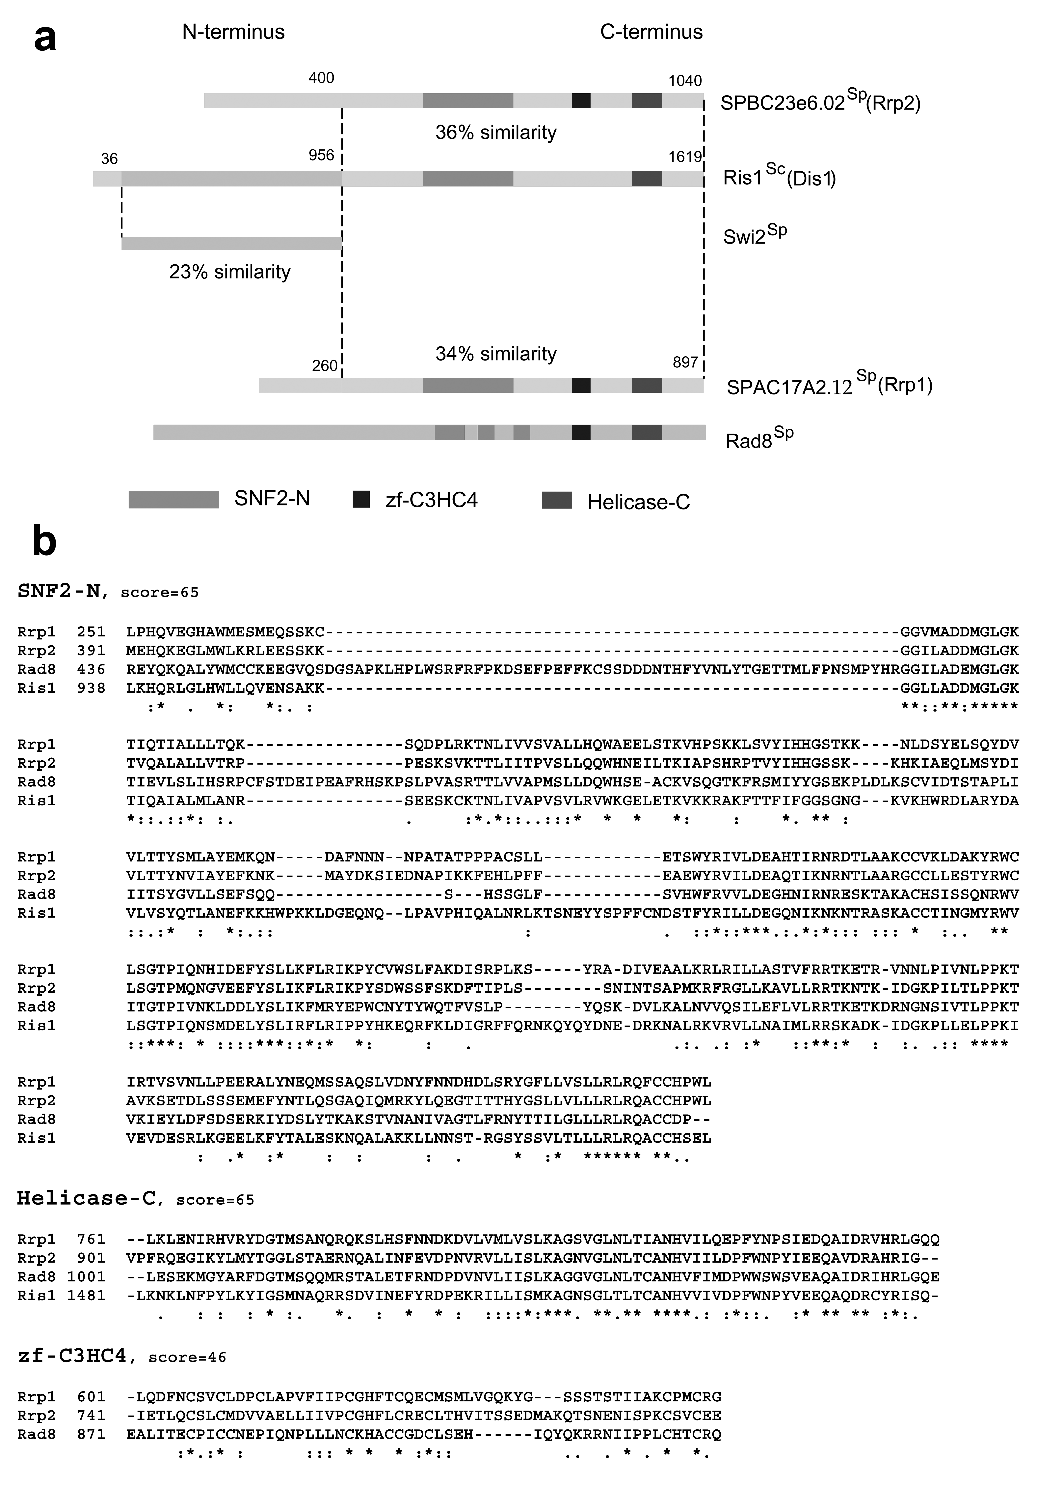
Figure 1.
Identification of two new proteins, Rrp1 and Rrp2, wih similarity to S. cerevisiae Ris1. (a) Schematic representation of the distribution of SNF2-N, Helicase-C and zf-c3HC4 domains in Rrp1, Rrp2, Ris1^{Sc} and Rad8. Superscripts; Sc: S. cerevisiae. Sp: S. pombe. (b) T-Coffee aligments of SNF2-N, Helicase-C and zf-c3HC4 domains in studied proteins. * represents identical residues, : represents conserved residues.

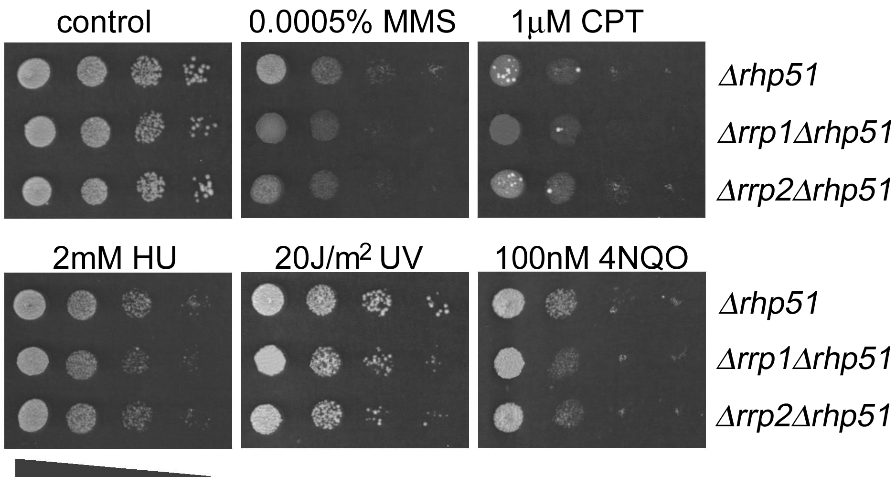
Figure 2.
Epistatis between rrp1 and rrp2 and rhp51 recombinase gene.
Serial dilutions of the indicated cultures were spotted on YES plates containing the given concentrations of drugs indicated or UV-irradiated. Plates were incubated for the required time (2-4 days) before being photographed.
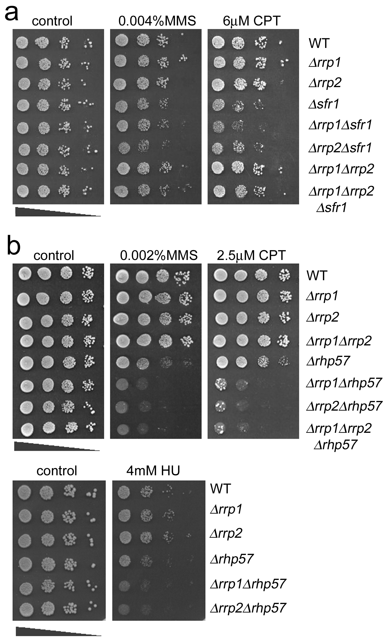
Figure 3.
Comparison of the sensitivity to MMS, CPT and HU of Δrrp1 and Δrrp2 mutants in Δsfr1 (a) and Δrhp57 (b) backgrounds. Serial dilutions of the indicated cultures were spotted on YES plates with the given concentrations of drugs shown.
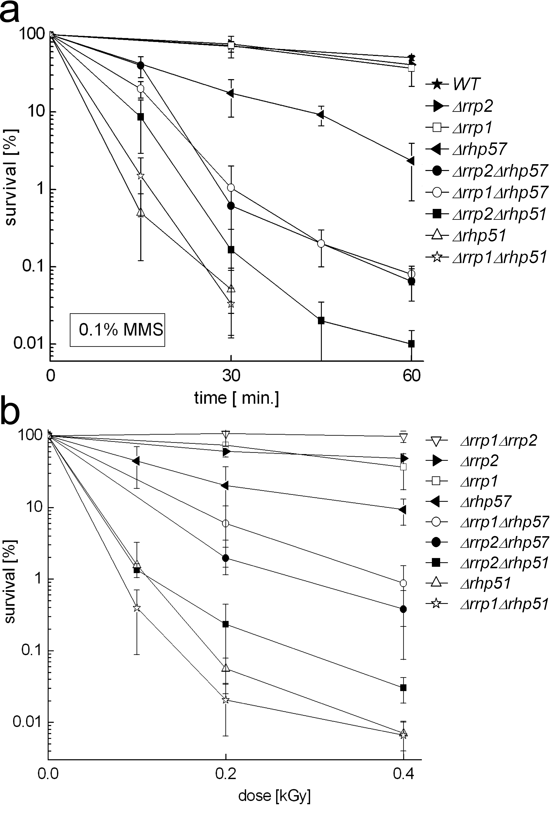
Figure 4.
Clonogenic survival of Δrrp1 and Δrrp2 mutants in Δrhp51 and Δrhp57 backgrounds. (a) Cells were exposed to 0.1 % MMS in liquid culture for the indicated time and plated on YES plates to assess viability. (b) Cells were exposed to γ rays in liquid culture and plated on YES plates to assess viability. Error bars represent Standard Deviation.

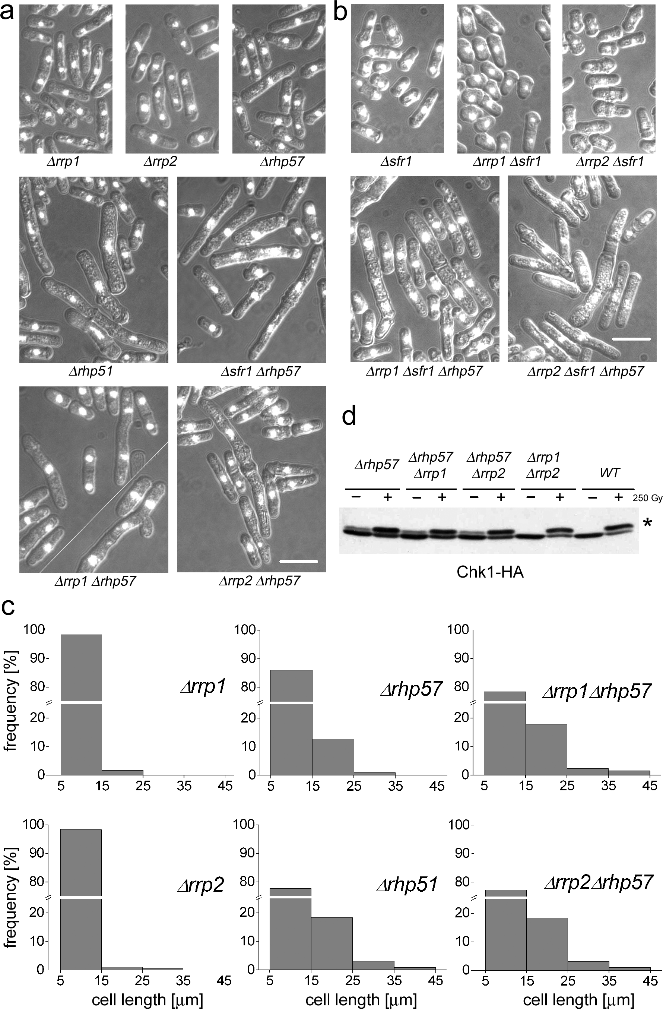
Figure 5.
Aberrant cell morphology in Δrrp1Δrhp57 and Δrrp2Δrhp57 mutants (a), but not in Δrrp1 Δsfr1 and Δrrp2Δsfr1 strains (b), distribution of cell length in Δrrp1, Δrrp2, Δrhp57, Δrrp1Δrhp57, Δrrp2Δrhp57 and Δrhp51 mutants (c), Western blot showing checkpoint activation in Δrrp1 Δrhp57, Δrrp2Δrhp57 and Δrrp1Δrrp2 mutants upon exposure to gamma irradiation (d). Cells were grown to mid log phase, fixed, stained with DAPI and examined by fluorescence microscopy. Scale bar represents 10 μm. * denotes phosphorylated form of Chk1.
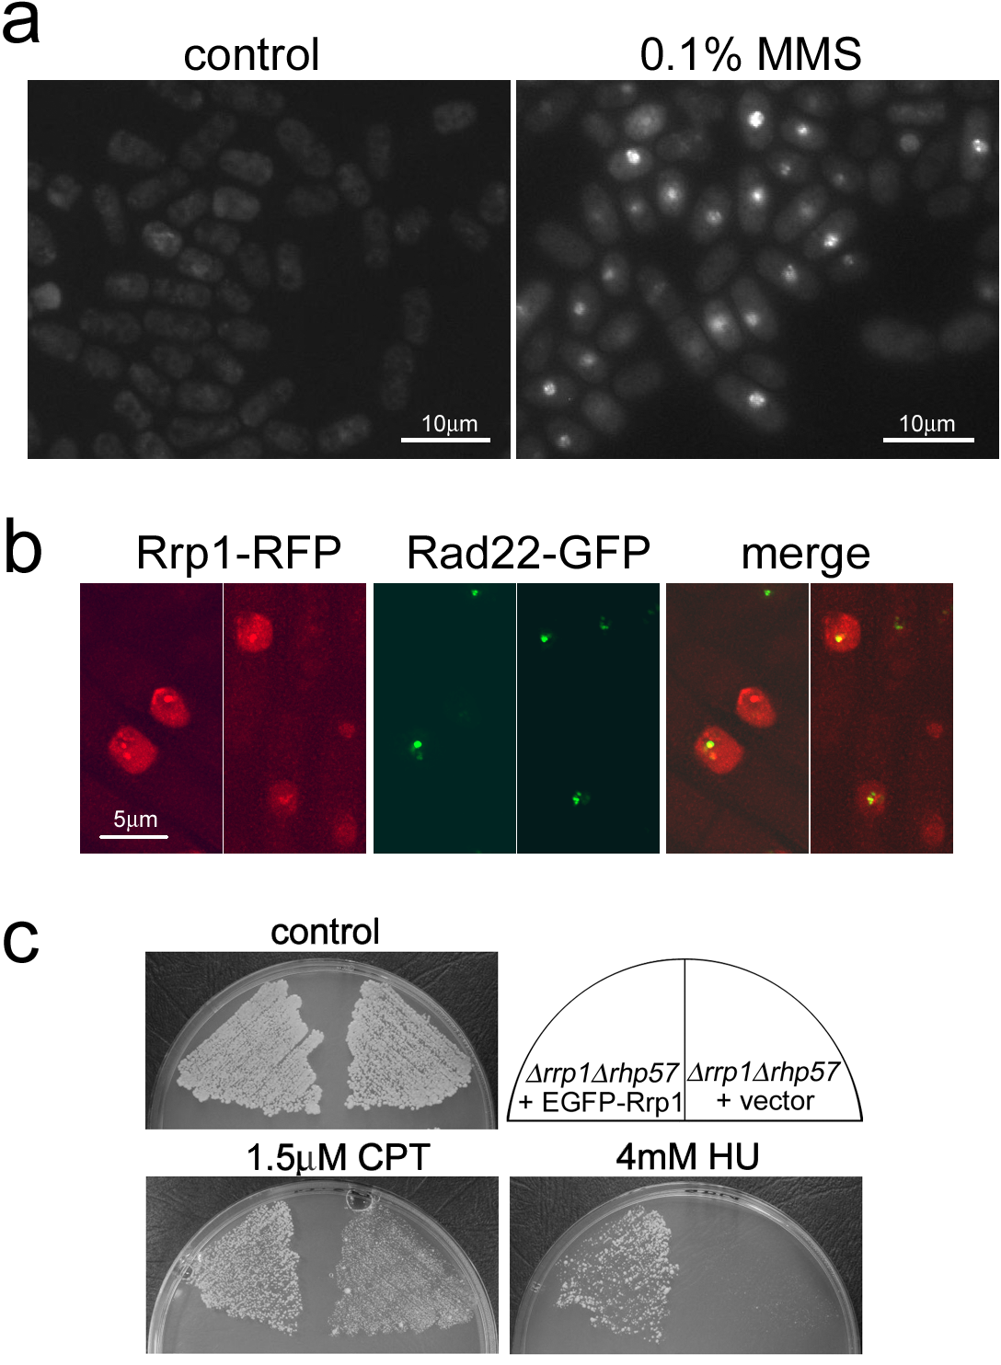
Figure 6.
Analysis of Rrp1 protein localisation.
(a) EGFP-Rrp1 nuclear localisation and foci formation in WT cells transformed with pREP41-EGFP-Rrp1 and exposed for 1 hour to 0.1 % MMS. (b) Co-localisation of RFP-Rrp1 nuclear foci with GFP-Rad22 upon exposure to 0.1 % MMS for 1 hour. (c) Complementation of the sensitivity of Δrrp1Δrhp57 mutant to CPT and HU by overexpression of EGFP-Rrp1.

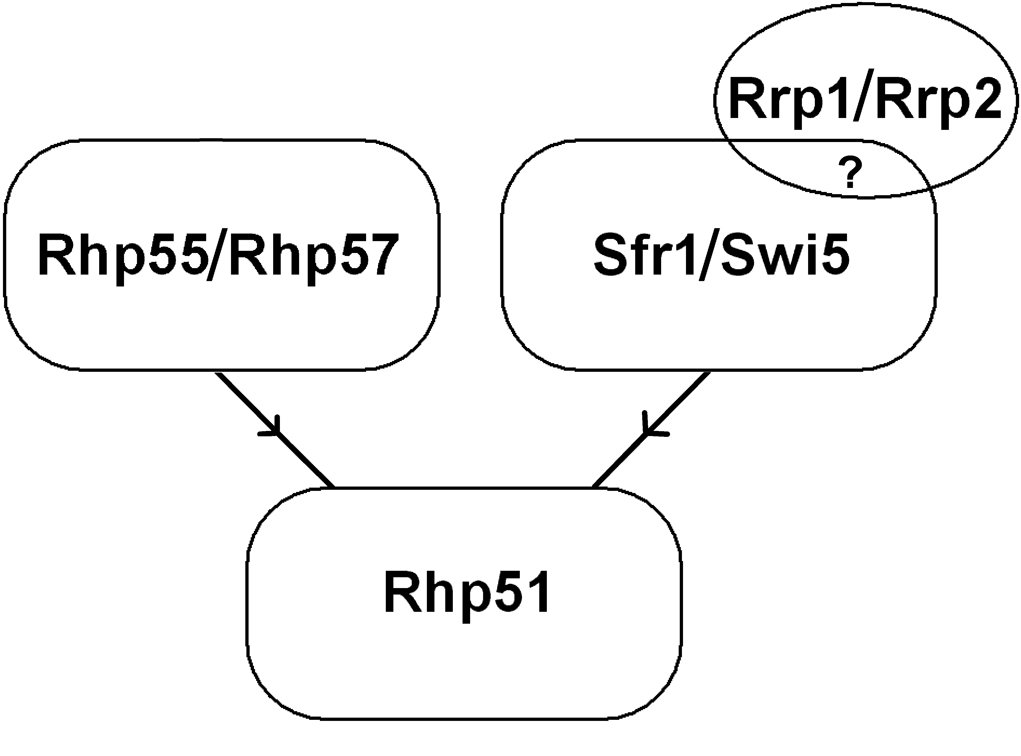
Figure 7.
Model of the interactions of Rrp1 and Rrp2 with the mediators of two branches of HR DNA repair pathway.

