Burial Surveillance detected significant reduction in HIV-related deaths in Addis Ababa, Ethiopia

Tekebash Araya^{1, 2}, Biruk Tensou², Gail Davey^{1, 3}, and Yemane Berhane^{1,4}
1. School of Public Health, College of Health Sciences, Addis Ababa University
2. Addis Ababa Mortality Surveillance Program (AAMSP), School of Medicine, Addis Ababa University
3. Brighton & Sussex Medical School, UK
4. Addis Continental Institute of Public Health (ACIPH), Addis Ababa, Ethiopia

Abstract
Objective: To determine the level of HIV-related mortality reduction following the introduction of large scale ART using burial surveillance system coupled with verbal autopsy in Addis Ababa, Ethiopia.
Methods: Prospective burial surveillance was established in 2001 at cemeteries in Addis Ababa. Verbal autopsy interviews were periodically conducted on a random sample of adult burials registered between 2001 and 2009. Independent physicians reviewed the completed VA questionnaires and assigned underlying causes of death. The period before 2005 was defined as pre-ART and that since 2005 the ART era. AIDS-specific mortality fractions were calculated by age, sex and year of burial to examine the mortality trends before and during the ART era.
Results: Of the 4239 verbal autopsy physician diagnoses, 1087 (25.6%) were ascribed to HIV-related deaths. HIV-related deaths in 2009 were 33% lower than in 2001. The proportion of HIV-related deaths was reduced from 44.0% in the pre-ART period to 20.0% in the ART era. A larger decline of death was observed in females (36.7%) than males (30%). A marked reduction of AIDS-specific mortality was observed in the age-group 30-39 years (from 69.1% pre-ART to 46.8% during the ART era); when compared with the 20-29 (from 60.5% pre-ART to 41.0% during ART) and 40-49 year-olds (49.7% pre-ART to 34.4% during ART provision).
Conclusion: Burial surveillance combined with verbal autopsy demonstrated a significant reduction in HIV-related deaths during the provision of free ART. Replication of burial surveillance is recommended in similar settings where vital registration system is nonexistent to track large-scale population level interventions.

Keywords: Burial surveillance, Verbal autopsy, HIV-related death, Pre-ART era, Free-ART era, Addis Ababa, Ethiopia.

Word count: Abstract=245; Text= 3490

Author affiliations & contact addresses:
Tekebash Araya (RN, BScN., MPH)
School of Public Health
Addis Ababa Mortality Surveillance Program (AAMSP)
College of Health Sciences, Addis Ababa University
Telephone: Cell phone, +251 911234655
Office, +251 116555320
E-mail: tekebash@gmail.com

Biruk Tensou (BSc, MSc-Demography)
Addis Ababa Mortality Surveillance Program (AAMSP)
College of Health Sciences, Addis Ababa University
Telephone: Cell phone, +251 911621600
Office, +251 116555320
E-mail: biruktensou@gmail.com

Gail Davey (MSc, MD)
Reader in Global Health
Brighton & Sussex Medical School
Telephone: Office, 44-1273-877662
E-mail: gailinaddis@hotmail.com/g.davey@bsms.ac.uk

Yemane Berhane (MD, MPH, PhD)
School of Public Health, College of Health Sciences, Addis Ababa University
Addis Continental Institute of Public Health (ACIPH), Addis Ababa, Ethiopia
Telephone: Office, + 251-(0) 114-168207
E-mail: yemaneberhane@ethionet.et

Corresponding author: Tekebash Araya
School of Public Health, College of Health Sciences,
Addis Ababa University,
Fax Number: + 251 115513099
Telephone: Cell phone, +251 911234655
Office, +251 116555320
E-mail: Tekebash@gmail.com
Authors’ Contributions:
Tekebash Araya & Yemane Berhane: Conceived and designed the study
Tekebash Araya & Biruk Tensou: Analyzed the data
Tekebash Araya, Yemane Berhane, Biruk Tensou & Gail Davey: Wrote the paper
Gail Davey & Yemane Berhane: Edited the paper including English language

All authors approved the final version

Conflict of interest: The authors declare that there is no conflict of interest

Introduction
Consistent and reliable cause-specific mortality data are essential for monitoring the success of antiretroviral therapy (ART). However, the chances of a death being registered and the causes of death being documented strongly depend on the socioeconomic status of the community and nation in which it occurs (Byass 2007). In resource-rich countries, mortality statistics are important part of vital registration systems. However, most sub-Sahara African countries lack systems to fully capture deaths and distribution of causes of death (Mathers et al. 2005). In these countries, data on cause-specific mortality often rely on records from medical facilities that are often incomplete, inaccurate and biased (Bennett et al. 2006); and hospital statistics are often not representative of the population because not all communities have equal access (Cooper et al. 1998). Health services utilization is often low and selective and most deaths occur at home, making it difficult to establish cause of death (Murray et al. 2007). For AIDS in particular, there is evidence that, some families withdraw HIV-diagnosed relatives from hospitals (Arthur et al. 2000).
There is a particular need to develop methods to evaluate the impact of interventions in countries with widespread HIV/AIDS epidemics. The ultimate goal of the scale-up of ART is to reduce HIV-related mortality (Porter & Zaba 2004); and monitoring the success of such programs relies on accurate evaluation of HIV-related deaths at population-level (Diaz et al. 2005). In African settings, studies on cohorts of patients on ART in demographic surveillance sites (DSS) have indicated population-level decline of AIDS-mortality after the introduction of ART (Jahn et al. 2008; Herbst et al. 2009). Similarly, a study using evidence from registers, coffin sales and funerals reported mortality reduction associated with ART (Mwagomba et al. 2010).
Similar to most sub-Saharan Africa, HIV/AIDS has been a great challenge to the Ethiopian health system and remains among the major causes of adult deaths over the past two decades (Seyoum et al. 2009). Recent HIV-prevalence figures indicate a generalized epidemic probably stabilizing or even declining in major urban areas (Berhane et al. 2008). In Ethiopia, a co-pay scheme ART was introduced in 2003 and free ART rollout was declared in January 2005 (Berhane et al. 2008). In Addis Ababa, HIV-prevalence among women aged 15-24 years has shown a decline of 35% between 1996 and 2005, falling from 20.7% to 13.5% in 2005 (MOH/NHAPCO 2006). A study using the burial surveillance method in same population indicated a decline in adult AIDS-mortality by 38.2% and 42.9% for men and women, respectively, between 2005 and 2007 (Reniers et al.2009).
The DSS in 20 countries, the Sample Registration System (SRS) in India, and the Disease Surveillance Points (DSP) in China regularly use verbal autopsy (VA) on a large-scale, to assess the causes-of-death structure of a defined population (Soleman et al. 2006). It has also been practiced in rural (Lulu & Berhane 2005; Chandramohan et al. 1998; Fantahun et al. 2006) and urban (Reniers et al. 2009; Araya et al. 2004) parts of Ethiopia to identify all causes-of-death. These studies clearly demonstrate the value of the VA method in resource-poor settings to support clinical observations and advance epidemiological studies.
In Addis Ababa, where the dead are buried and not cremated, registration of burials provides mortality data with background characteristics and address of a deceased. A convenient feature of the burial surveillance is that it taps into an existing infrastructure of burial sites (Sanders et al 2003). While several scientific reports describe the surveillance of burials, the purpose of this paper is to describe the application of burial surveillance method complemented by VA technique as a timely source of mortality data to determine the level of HIV-related mortality following the introduction of large-scale ART in Addis Ababa, Ethiopia.

Methods
Description of study area
Burial surveillance has been conducted since 2001 in Addis Ababa, the capital of Ethiopia. In 2001, the projected population of Addis Ababa based on the 1994 census was estimated at 2.6 million (CSA 1995). In the 2007 census, the population was estimated at 2739551 comprised 1305387 (47.6%) males and 1434164 (52.4%) females; two-thirds (1807447, 66%) were in the age group 15-45 years with 948784 (53%) females. By religion, most (75%) are Orthodox Christian, 16% Muslim, and 8% Protestant while the rest are Catholics, or followers of traditional religions (CSA 2010).
A governmental co-pay ART program was introduced in 2003. Patients possessing a poverty certificate were given free ART. In January 2005, free ART was available to everyone, and the number of patients benefiting from the program increased quickly (Berhane et al. 2008; Reniers et al. 2009). By the end of January 2009, a total of 50,705 patients had ever started ART (MOH-HAPCO 2009). As would be expected, the rapid increases in enrollment rates were accompanied by important reductions in AIDS-mortality (Reniers et al. 2009).

Data sources
The burial surveillance data registered at all cemeteries (N=88) in Addis Ababa was the primary source of data. On the funeral day, information about the deceased including name, age, sex, address and other identifiers is collected by trained cemetery clerks who interview the deceased’s relative while performing prerequisites for funeral. Detailed methodology of the burial surveillance is described elsewhere (e.g., Sanders et al. 2003; Araya et al. 2004; Reniers et al. 2009). Un-identifiable bodies are sent by police or hospitals to a municipal-based cemetery named ‘Baytewar’ for burial. This unique cemetery comprises >15% of all burials lacking addresses; and more than 90% have no name, age, or other identifiers (Sanders et al. 2003). Lay cause of death within burial surveillance has been validated as a useful instrument by which to measure the impact of ART on HIV-related mortality at population-level (Reniers et al. 2009).
The second source of data used in this study was the VA. Verbal autopsy is a method of identifying the cause of death based on an interview with next of kin or other caregivers regarding symptoms, signs, and circumstances preceding death (Soleman et al. 2006). It has been used by other investigators to assess HIV-related deaths (Kamali et al. 1996). The World Health Organization (WHO) has standardized the VA method and it is used as the only practical option in developing countries for ascertaining cause of death (Baiden et al. 2007
In this study, verbal autopsies were conducted on a one-in-ten random sample of 60036 adult burials registered in three months of 2001, in eight months of 2003, in four months of 2006, all of 2007 and 2008, and for seven months of 2009. A pair (male and female) of trained interviewers by tracing the home address of the deceased. The interviews were undertaken between one and six months (mean=3.2 months) from the date of death. Each interview lasted between 30 to 45 minutes.

Estimating cause of death
In this study, two physicians independently reviewed the completed questionnaires and assigned underlying cause of death and, where possible, contributing and immediate causes of death. The physicians were given a copy of the ICD10 (WHO 1993) and forms on which to record diagnosis. A non-physician research assistant checked for consistency of diagnosis between the two physicians and assigned final diagnosis and ICD10 code. A diagnosis was considered consistent when both physicians agreed on the underlying cause of death. First time consistent diagnoses were about 70% of interviewed VA questionnaires. If physicians disagreed about the cause of death, the questionnaire was reviewed by a third independent physician. If all three physicians failed to reach a consistent diagnosis, the questionnaire was reviewed by panel and, where possible, a diagnosis was assigned by consensus. A cause of death for which physicians could not assign specific-diagnosis was remained as undetermined (5%).

Data processing and analysis
For quality assurance, clearly documented data cleaning syntaxes in Access and STATA software were used. Cleaned data were prepared for analysis by stripping identifiers from the master database. As the VA procedure requires complete address of the deceased, all ‘Baytewar’ burials were excluded from the VA procedures. This particular study focuses on adult deaths [age>12 years] (Table 1). Among the households selected for VA interviews, on average 70% of them were successfully completed while the rest were not interviewed for various reasons (e.g., 20% households not found, 5% care giver unavailable and 5% refusals). Completed adult VA questionnaires with assigned physician diagnosis were analyzed.
We defined HIV-related death as a death resulting from AIDS assigned by panel of physicians. In this study AIDS-specific-mortality-fraction is the proportion of HIV-related deaths assigned by physicians by the total number of VAs reviewed by physicians. All VA-diagnoses were categorized into major causes of death and analyzed to look at the patterns of all cause mortality compared to HIV-related deaths in the years VAs were conducted. Mortality due to HIV by-age was computed to identify the most severely affected age-group. AIDS-specific-mortality-fractions were calculated by sex and year of burial to evaluate the mortality trends. The study period was dichotomized into ‘pre-ART era’ (before 2005) and ‘ART era’ (since 2005).

Ethical considerations
Ethical clearance was secured from the Institutional Review Board (IRB), Faculty of Medicine of Addis Ababa University with biannual renewal; and at national level, from the National Health Research Ethics Review Committee of the Ministry of Ethiopian Science and Technology with annual renewal. Official permission was obtained from religious leaders, municipal officials and cemetery authorities before initiation of burial registration. Before obtaining the necessary information, cemetery clerks explain the purpose of the surveillance to close relatives or friends of the deceased. Before VA interviewers conducted interviews, consent was obtained from the closest adult caregiver of the deceased.

Results
A total of 4239 adult VA diagnoses were analyzed: 200 from 2001; 790 from 2003 and 3249 from 2006-2009. Slightly more than half (2123, 50.1%) of the diagnoses were for males and 2116 (49.9%) for females. Deaths due to communicable diseases varied between 15% in 2003 and 16% in 2009; and due to injuries between 6.45% in 2003 and 7.14% in 2009 (New Figure 1). The overall proportion of HIV-related deaths was 25.6% (n=1087) comprising 22.9% (n=485) males and 28.5% (n=602) females. The trend of HIV-related deaths among males declined from 40.6% in 2001 to 10.6% in 2009. The same pattern of decline was also observed among females (from 50.6% in 2001 to 13.9% in 2009) (Figure 1). This equates to a decline of about 30% for males and 37% for females from the pre-ART era to three years after the introduction of free ART. Mortality due to AIDS declined significantly from 44.0% in the pre-ART era to 20.1% in the free ART era (Figure 2).
Before the provision of free ART, HIV-related deaths were highest in the age group 30-39 years (69.1%), followed by 60.5% and 49.7% in the 20-29 year and 40-49 year groups, respectively. The same age-groups were also highly likely to die of AIDS after the introduction of free ART with 46.8%, 41.0% and 34.4% among 30-39, 20-29 and 40-49 year-olds, respectively (Figure 3).
A more pronounced reduction in AIDS-specific mortality was observed in the 30-39 year-olds when compared with the 20-29 and 40-49 year-olds. Deaths ascribable to AIDS in the 30-39-year-olds decreased from 69.1% pre-ART to 46.8% during the ART era; while for the 20-29 and 40-49 year-olds it decreased from 60.5% pre-ART to 41.0% after free ART, and from 49.7% pre-ART to 34.4% after free ART provision, respectively (Figure 3).

Discussion
While there are abundant intervention programs offering prevention, treatment and care of AIDS patients, documentation of their effectiveness at the population level is limited (Assefa et al. 2009). In Ethiopia, data on the effectiveness of HIV treatment at population level are scarce and appropriate systems to evaluate their interventions within the health care system are also lacking (Reniers et al. 2009). While there are several reports indicating significant decline of HIV-prevalence (MOH/HAPCO 2007), and adult deaths within the years immediately following introduction of ART (Reniers et al.2009), studies documenting the level of AIDS-attributable mortality after accelerated access to ART are scarce. Hence, we believe the Burial Surveillance approach in combination with VA data can bridge that gap.
Verbal autopsies are used as a substitute for hospital data to monitor cause-specific mortality; and physician VA diagnosis has been validated among adult deaths in African countries (Chandramohan et al. 1998) including Ethiopia (Fantahun et al. 2006). Mortality surveillance systems using VA procedures represent a cost-effective and sustainable medium-term solution to this problem (Soleman et al. 2006). In this paper, we have documented the impact of large-scale ART-intervention on AIDS-mortality using a combination of burial surveillance and VA methods. The results demonstrate significant reduction of mortality attributed to AIDS during the study years.
Scattered studies have demonstrated the impact of ART on AIDS mortality in different African settings. A decline in population-level mortality was observed shortly after the introduction of ART (Jahn et al. 2008; Herbst et al. 2009). These studies mainly focus on rural-based DSS with relatively delineated, smaller populations (Herbst et al. 2009) and ART cohorts (Jahn et al. 2008). Our earlier study using the same population and similar methods documented the decline of HIV-related death using lay-reported cause of death from burial surveillance. This study also suggested that periodic re-anchoring of lay-reports may be necessary in the absence of continuous VA data (Reniers et al. 2009). The availability of continuous VA will further complement previous studies without any underlying assumptions.
Our results showed a significant (33%) decline in HIV-related mortality in a large urban area, with a substantial population. In 2007, HIV-related mortality declined by 50.0% and 54.0% for adult males and females, respectively. By the end of the study period, the proportion of HIV-related deaths was almost halved (26.0% vs. 41.0% for males and 27.0% vs. 51.0% for females). This is consistent with results using lay-reported cause-of-death after accelerated-ART provision between 2005 and 2007 [40.6% vs. 15.8%] (Renders et al. 2009). Before free ART was introduced, it was evident that HIV-related mortality was increasing (WHO, UNAIDS, UNICEF 2008).
The findings of our study are consistent with reports in Addis Ababa which showed reduction of HIV-related deaths following years of ART scale-up (WHO/ UNAIDS/UNICEF 2008). Studies conducted in similar African settings such as Botswana and Malawi were highly suggestive of an association between AIDS-mortality and ART-scale-up programs (Stover et al. 2008; Mwagomba et al. 2010). Likewise, the immediate reduction in HIV-related mortality observed in this study just after accelerated free-ART is highly indicative of such a relationship. In this regard, using burial surveillance method with VA technique to measure such outcome is an alternative technique of documenting population-level cause of death and evaluating large-scale interventions, like ART.
We argue that burial surveillance system is feasible and less-costly for resource-poor settings like Ethiopia where cremation is not practiced and burials are conducted at dedicated religious or municipal burial sites. More importantly, in a traditional African community like Ethiopia where religious institutions are influential, information generated using this system may have more social and cultural acceptance, in turn influencing policy decisions.
For determining the level of HIV-related outcomes, mortality data are the most basic health outcome indicator to measure population health status and effectiveness of interventions (Mathers et al. 2005). Thus, burial surveillance method offers opportunities to evaluate HIV-related mortality and to provide a solid platform for policies and decisions.

Conclusion
In an urban setting like Addis Ababa, where vital registration is absent or incomplete, hospital deaths and clinical records are scarce, and cremation is not practiced, burial surveillance is a cost-effective method of capturing deaths at population level. The use of VA is vital in documenting patterns of cause of death and estimating HIV-related deaths in resource-poor settings during the scale-up of ART. We recommend assisting the establishment of municipal infrastructure and controlled cemeteries to strengthen burial surveillance in resource-poor settings.

Acknowledgements
The Addis Ababa Mortality Surveillance Program has been made possible with major financial support from the AIDS Foundation of Amsterdam, the Netherlands (grant no. 7022); the WHO (Second Generation Surveillance on HIV/AIDS, contract no. SANTE/2004/089-735); the Centers for Disease Control and Prevention (EPHA-CDC cooperative agreement no.U22/CCU022179); the Mellon Foundation (pilot project grant to the Population Studies Center of the University of Pennsylvania); and a Hewlett Foundation grant to the University of Colorado at Boulder for the African Population Studies Research and Training Program. Institutional support from the Faculty of Medicine of Addis Ababa University and the Ethiopian Public Health Association is obtained. Religious Leaders and the Addis Ababa Labour and Social Affairs Bureau facilitated our access to cemeteries. Physicians who reviewed the VA questionnaires are grateful.

References
Araya T, Reniers G, Schaap A et al. (2004) Lay diagnosis of causes of death for monitoring AIDS mortality in Addis Ababa, Ethiopia. Tropical Medicine & International Health 9,178–186.

Arthur G, Bhatt SM, Muhindi D, Achiya GA, Kariuki SM & Gilks CF (2000) The changing impact of HIV/AIDS on Kenyatta National Hospital, Nairobi from 1988/89 through 1992 to 1997. AIDS 14, 1625–1631.

Assefa Y, Jerene D, Lulseged S, Ooms G, Damme WV (2009) Rapid Scale-up of ART in Ethiopia: Successes and System-wide Effects. PLoS Medicine 6(4), http://www.plosmedicin.org. [Accessed 29 December 2010].

Baiden F, Bawah A, Biai S et al. (2007) Setting international standards for verbal autopsy. Bulletin of the World Health Organization 85(8), 569-648.
Bennett S, Boerma, JT, & Brugha R (2006) Scaling up HIV/AIDS evaluation. The Lancet 367, 79-82.

Berhane Y, Mekonnen Y, Seyoum E, Gelmon L & Wilson D (2008) HIV/AIDS in Ethiopia-an epidemiological synthesis. Addis Ababa: HIV/AIDS Prevention & Control Office and Global AIDS Monitoring & Evaluation Team. http://www.worldbank.org/AIDS. [Accessed 15 November 2010].

Bhopal RS (2002) Concepts of Epidemiology: An integrated introduction to the ideas, theories, principles and methods of epidemiology, Oxford University Press.

Byass P (2007) Who needs cause-of-death data? PLoS Medicine 4, e333.

Chandramohan D, Maude GH, Rodrigues LC et al. (1998) Verbal autopsies for adult
deaths: Their development and validation in a multicentre study. Tropical Medicine &
International Health 3(6), 436-446.

CSA (1995) The 1994 Population and Housing Census of Ethiopia. Results for Addis Ababa. Central Statistical Authority (CSA), Office of Population and Housing Census Commission, Addis Ababa.

CSA (2010) The 2007 Population and Housing Census of Ethiopia: Results for Addis Ababa City Administration. Statistical Report. Central Statistical Agency (CSA), Population Census Commission, Addis Ababa.

Cooper RS, Osotimehin B, Kaufman JS, Forrester T (1998) Disease burden in sub-Saharan Africa: what should we conclude in the absence of data. The Lancet 351, 208–210.

Diaz T, Loth G, Whitworth J & Sutherland D (2005) Surveillance methods to monitor the impact of HIV therapy programmes in resource-constrained countries. AIDS 19(Suppl.2), S31–S37.

Fantahun M, Fottrell E, Berhane Y et al. (2006) Assessing a new Approach to verbal autopsy interpretation in a rural Ethiopian community: the InterVA Model. Bulletin of the World Health Organization 84, 204-210.

Hebest JA, Cooke SG, Bärnighausen T, KanyKany A, Tanser F, & Newell M (2009) Adult mortality and antiretroviral treatment roll-out in rural KwaZulu-Natal, South Africa. Bulletin of the World Health Organization 87:754-762.

Jahn A, Floyd S, Crampin AC, Mwaungulu F, Mvula H, Munthali F et al.(2008) Population-level effect of HIV on adult mortality and early evidence of reversal after introduction of antiretroviral therapy in Malawi. Lancet 371 (9624):1603–1611.

Jerene D, Naess A & Lindtjorn (2006) Antiretroviral therapy at a district hospital in Ethiopia prevents death and tuberculosis in a cohort of HIV patients. AIDS Research and Therapy doi: 10.1186/1742-6405-3-10http://www.aidsresearchtherapy.com/content/3/1/10.[Accessed on 20 April 2011].
Lulu K & Berhane Y (2005) The use of simplified verbal autopsy in identifying causes of adult death in a predominantly rural population in Ethiopia. BMC Public Health 5, 58.

Mathers CD, Fat DM, Inoue M, Rao C & Lopez AD (2005) Counting the dead and what they died from: an assessment of the global status of cause of death data. Bulletin of the World Health Organization 83, 171–177.

MOH/HAPCO (2006) AIDS in Ethiopia. Sixth Report.

MOH/HAPCO (2007) Accelerated access to HIV/AIDS Prevention, Care and Treatment in Ethiopia Road Map for 2007–2008. Health Programs Department, HAPCO.

MOH/HAPCO (2009). Monthly HIV care and ART update. Available from: http:// www.etharc.org/arvinfo/index.htm [Accessed 28 June 2010].

Murray CJL, Lopez AD, Barofsky JT, Bryson-Cahn C, Lozano R (2007) Estimating Population Cause-Specific Mortality Fractions from in-Hospital Mortality: Validation of a New Method. PLoS Medicine 4(11), e326.

Mwagomba B, Zachariah R, Massaquoi M, Misindi D, Manzi M, et al. (2010) Mortality Reduction Associated with HIV/AIDS Care and Antiretroviral Treatment in Rural Malawi: Evidence from Registers, Coffin Sales and Funerals. PLoS ONE 5(5).

Porter K & Zaba B (2004) The empirical evidence for the impact of HIV on adult mortality in the developing world: data from serological studies. AIDS 18(Suppl 2), S9-S17.

Quigley MA, Chandramohan D, Setel P, Binka F & Rodrigues LC (2000) Validity of data-derived algorithms for ascertaining causes of adult death in two African sites using verbal autopsy. Tropical Medicine & International Health 5, 33–39.

Reniers G, Araya T, Davey G et al.(2009) Steep declines in population-level AIDS mortality following the introduction of antiretroviral therapy in Addis Ababa, Ethiopia. AIDS 23, 511-518.

Sanders E, Araya T, Kebede D, Schaap A, Nagelkerke N & Coutinho R (2003) Mortality impact of AIDS in Addis Ababa, Ethiopia. AIDS 17, 1209–1216.

Soleman N, Chandramohan D & Shibuya K (2006) Verbal autopsy: current practices and challenges. Bulletin of the World Health Organization 84, 239-245.

Stover J, Fidzani B, Molomo BC, Moeti T, Musuka G (2008) Estimated HIV Trends and Program Effects in Botswana. PLoS ONE 3(11), e3729. http://www.plosone.org. [Accessed 20 December 2010].

Tensou B, Araya T, Telake DS, Byass P, Berhane Y, Kebebew T, Sanders EJ, and Reniers G (2010) Evaluating the InterVA model for determining AIDS mortality from verbal autopsies in the adult population of Addis Ababa. Tropical Medicine & International Health 15(5), 547-553.

WHO/AIDS (2003) Treating three million by 2005: Making it happen. The WHO Strategy, Geneva.

WHO: ICD-10 (1993). International statistical classification of diseases and related health problems. Geneva: World Health Organization.

WHO/UNAIDS/UNICEF (2008) Epidemiological Fact Sheet on HIV and AIDS, Ethiopia, 2008 update.

Table 1. Number and percentages distribution of registered burials by cemetery type, age and sex as reported by caregivers of the deceased (2001-2009), Addis Ababa, Ethiopia

Cemetery type | Total number of registered Burials | Percentage
Total Burials | 159 774 | 100.00
All Baytewar Burials | 25 219 | 15.80
All Non-Baytewar Burials:  Child Non-Baytewar (age<12 years)  Adult Non-Baytewar (age>12 years)  Sex:  Female  Male  Sub-total with sex record  Missing sex record | 134 555  15 949  118 606  58 616  59 976  118 592  14 | 84.20  11.85  88.15  49.43  50.57  99.99  0.01

Figure X. Trend in annual all causes of death using verbal autopsy physician
diagnosis, 2001-2009, Addis Ababa, Ethiopia

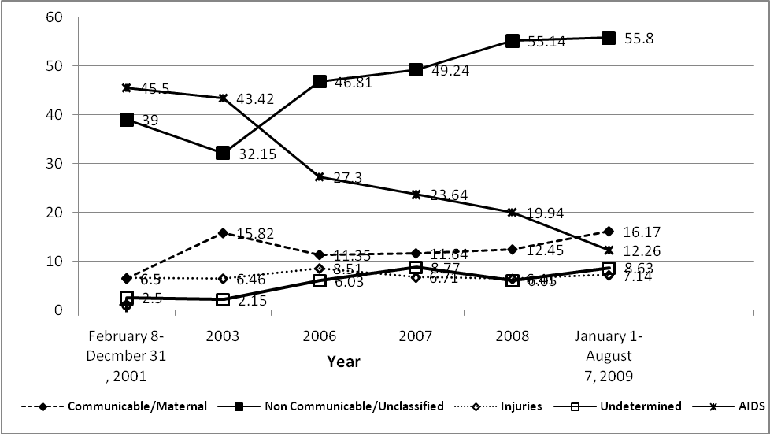

Fig 2. Trend of HIV-related causes of death by sex and year of
death of the deceased, 2001-2009, Addis Ababa, Ethiopia.

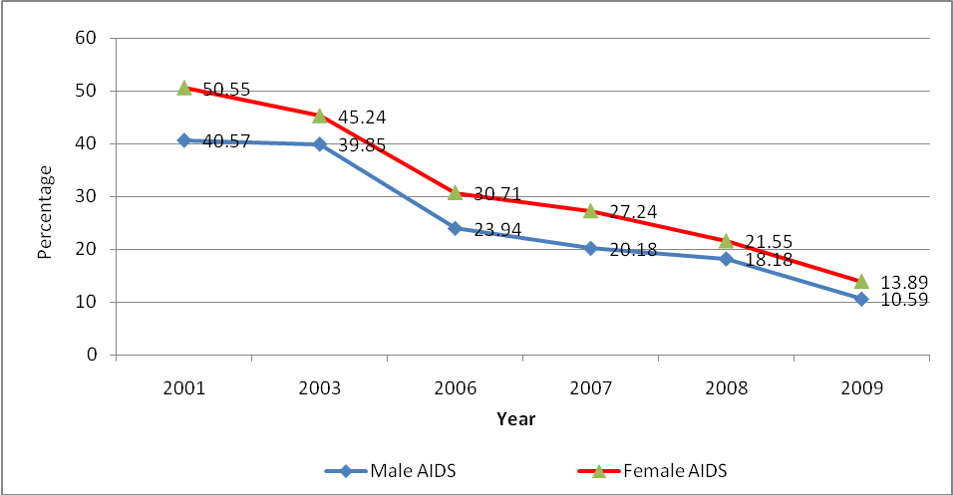

Fig. 3. Overall HIV-related mortality fractions before and during the
ART-era, 2001-2009, Addis Ababa, Ethiopia.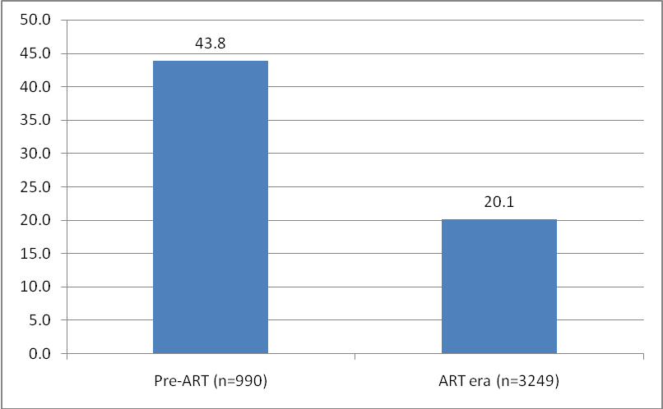

Fig. 4. HIV-related mortality fractions by ten-year age group of the
deceased and time before-and after the introduction of free-ART, 2001-2009, Addis
Ababa, Ethiopia.

