xx

Table of Contents
9.5.8 Podoconiosis (nonfilarial elephantiasis)
Essentials
Historical perspective
Aetiology, genetics, pathogenesis, and pathology
Epidemiology and ecology
Prevention
Clinical features
Differential diagnosis
Clinical investigation
Treatment
Prognosis
Economic burden and social stigma
Likely developments
Return to the top
med-9780199204854-chapter-090508
9.5.8 Podoconiosis (nonfilarial elephantiasis)
Headline notes:
- Description of genetic susceptibility modified to include information from recent genomewide association study.
- Progress made in Global Awareness is outlined.
Gail Davey
Return to the top
med-9780199204854-div1-090508001
Essentials
Podoconiosis is an entirely preventable, noncommunicable, geochemical elephantiasis caused by exposure of bare feet to irritant clay soils. It is found across tropical Africa, central America, and north India where such soils coexist with high altitude, high rainfall, and low income. Prodromal symptoms include itching and a burning sensation in the foot; early changes include spreading or ‘splaying’ of the forefoot, swelling of the sole of the foot, leakage of colourless ‘lymph’ fluid, and moss-like or velvet-like changes in the skin; in advanced disease there is soft fluid (‘water bag’) or hard fibrotic (‘leathery’) swelling. Early stage disease is reversible by good foot hygiene and use of socks and shoes. Late stage disease, which results in considerable economic and social difficulties, is treated with elevation and compression of the leg and (if necessary) debulking surgery. Early stages are reversible given good foot hygiene whereas late stages result in considerable economic and social difficulties and, despite treatment, may never fully resolve.
Return to the top
med-9780199204854-div1-090508002
Historical perspective
The Persian physician Rhazes first distinguished elephantiasis ‘of the Greeks’ (lepromatous leprosy) from that ‘of the Arabs’ (most probably nonfilarial elephantiasis) in c.905 ce. Towards the end of the 19th century, the discrepancy between the distributions of elephantiasis and filariasis in North Africa, central America, and Europe, prompted investigation by Hirsch and others. In the 1920s, persistently negative tests for filaria led Robles to infer that the elephantiasis he saw in Guatemala was an endemic condition associated with walking barefoot. Ernest Price’s extensive work on the ecology and pathogenesis of the condition through the 1970s and 1980s led him to propose the term ‘podoconiosis’, from the Greek words ποδοσ (foot) and κονοσ (dust), which has gained widespread acceptance.
Return to the top
med-9780199204854-div1-090508003
Aetiology, genetics, pathogenesis, and pathology
The climatic factors necessary to produce irritant clays include altitudes over 1000 m above sea level, and seasonal rainfall over 1000 mm annually. These conditions contribute to the steady disintegration of lava and the reconstitution of the mineral components into silicate clays with particle size less than 2 μm.
Not everyone exposed to irritant soil develops podoconiosis, but family clustering has long been observed. Recent genetic studies have demonstrated high heritability of the trait and segregation analysis suggests the presence of an autosomal codominant major gene conferring susceptibility to podoconiosis. A recent genomewide association study has demonstrated association between variants in HLA Class II loci and podoconiosis, suggesting that the disease may be a T-cell-mediated inflammatory disease.
Histological examination of the lymph nodes of affected individuals shows a ‘starry sky’ clustering of small lymphocytes and plasma cells around macrophages in the cortex. Electron microscopy shows that the macrophage phagosomes contain particles of stacked kaolinite (Al2Si2O5(OH)4). The lymph node sinuses are filled with lymphocytes, suggesting that obstruction to lymph flow occurs in the afferent lymphatics rather than the nodes themselves. Light microscopy shows subendothelial oedema and subsequent collagenization of afferent lymphatics reducing and finally obliterating the lumen.
Return to the top
med-9780199204854-div1-090508004
Epidemiology and ecology
Podoconiosis is found in highland areas of tropical Africa, central America, and north-west India. Areas of high prevalence have been identified in Uganda, Tanzania, Kenya, Rwanda, Burundi, Sudan, and Ethiopia, to the east side of Africa, and in Equatorial Guinea, Cameroon, the islands of Bioko, São Tomé and Principe, and Cape Verde to the west (Fig. 9.5.8.1). The condition has been reported in the central American highlands from Mexico, south to Ecuador. Although filarial elephantiasis predominates in India, podoconiosis has been reported from north-west India, Sri Lanka, and Indonesia.
Although studies in Ethiopia suggested gender ratios between 1:1.4 and 1:4.2, the most recent recording was 1:0.98, which was not significantly different from the zonal gender ratio. All major community-based studies have shown onset in the first or second decade and a progressive increase in prevalence up to the sixth decade.
Development of podoconiosis is closely associated with living and working barefoot on irritant soils. Farmers are at high risk, but the risk extends to any occupation with prolonged contact with the soil, and the condition has been noted among gold-mine workers and weavers whose feet operate loom pedals dug into pits in the ground.
Return to the top
med-9780199204854-div1-090508005
Prevention
Evidence suggests that primary prevention should consist of avoiding prolonged contact between the skin and irritant soils through regular use of robust footwear. However, footwear remains an unaffordable luxury for residents of most affected areas. Use of matting on the floors of traditional houses may also diminish risk.
Secondary prevention (prevention of progression of early symptoms and signs to overt elephantiasis) involves training in foot Page number: 1427 hygiene (washing daily with soap and water), and encouraging the use of socks and shoes. Progression can be completely averted if these measures are strictly adhered to, but compliance must be lifelong. Relocation from an area of irritant soil or adoption of a new occupation are also effective measures, but may not be feasible for the patient.
Return to the top
med-9780199204854-div1-090508006
Fig. 9.5.8.1 Distribution of podoconiosis across tropical Africa and islands.
Image: med-9780199204854-graphic090508001.jpg: 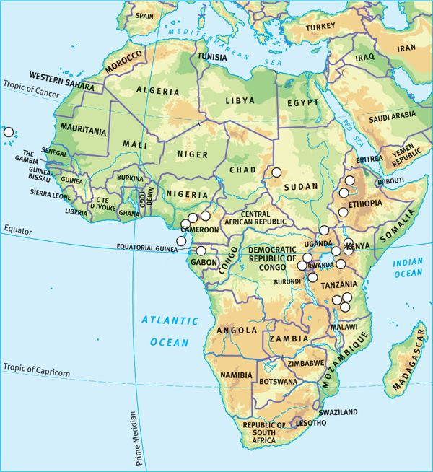

Clinical features
The disease process is usually described in three phases: prodromal, early, and advanced. Prodromal symptoms include itching of the skin of the forefoot, a burning sensation in the foot and lower leg, ‘chills’, or generalized joint pains. The affected person may describe exacerbation of symptoms when they try to walk long distances or do hard physical work.
Early changes include spreading or ‘splaying’ of the forefoot, swelling of the sole of the foot, leakage of colourless ‘lymph’ fluid from the foot, and changes in the skin so that it looks like moss or velvet (Fig. 9.5.8.2). Sometimes the feet become darker in colour, the toes become less mobile, and lumps with a mossy-looking surface develop on the top of the foot. The affected person may report limb aches, heaviness of the lower leg and foot, and odour from the lymph leak, which may attract flies. Acute episodes (usually asymmetrical and often unrelated to superimposed bacterial or fungal infection), cause fever, rigors, and a rapid increase in pain and swelling of the leg.
As advanced elephantiasis develops, both legs and feet will be affected, though one is usually more severely affected than the other. Even if footwear is available, it is difficult to wear by this stage and may increase discomfort in severely swollen feet. In advanced disease, the swelling persists as one of two types. Soft, fluid swelling is often known as ‘water-bag’ type, and will typically be linked to lymph fluid leakage (Fig. 9.5.8.3). Hard, fibrotic swelling is termed ‘leathery’ type, and is often associated with many hard skin nodules (Fig. 9.5.8.4).
Return to the top
med-9780199204854-div1-090508007
Differential diagnosis
Podoconiosis must be distinguished from filarial elephantiasis (see Table 9.5.8.1) and chronic sepsis secondary to plantar ulceration or infected trauma in leprosy.
Return to the top
med-9780199204854-div1-090508008
Clinical investigation
In the community, diagnosis is usually based on the features given in Table 9.5.8.1. However, if nodulectomy is to be considered, filarial Page number: 1428 disease may be ruled out by examining a midnight blood sample in countries where Wuchereria bancrofti is prevalent.
Fig. 9.5.8.2 Early changes—oedema, block toes, changes in skin colour (here related to the pattern of the open sandal worn), lymph ooze, and early mossy changes around interdigital clefts.
Image: med-9780199204854-graphic090508002.jpg: 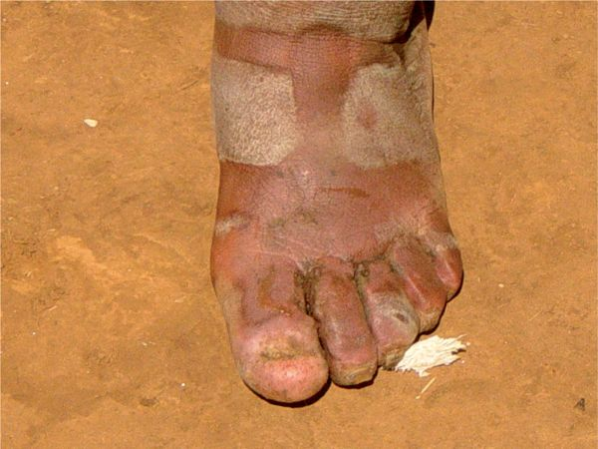

Return to the top
med-9780199204854-div1-090508009
Fig. 9.5.8.3 ‘Water-bag’ type swelling: patient in her early 20s.
Image: med-9780199204854-graphic090508003.jpg: 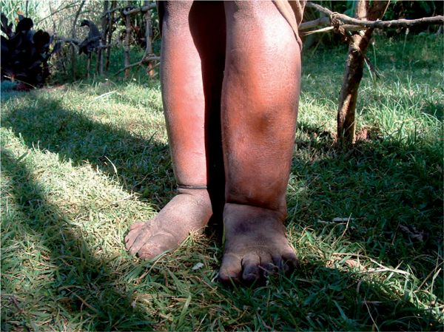

Treatment
Treatment of advanced disease encompasses all the above-mentioned secondary prevention measures, plus elevation and compression of the affected leg, and, if necessary, nodulectomy. To be successful, the legs must be elevated to or above the level of the heart for at least 18 h. Where electricity is available, intermittent compression machines may reduce swelling rapidly, but twice-daily application of elastic bandages is also effective. Charles' operation (removal of skin, subcutaneous tissue, and deep fascia to lay the muscles and tendons bare, followed by grafting of healthy skin), is no longer recommended, as long-term results are disappointing. Nodulectomy may be required if one or two nodules prevent use of footwear. Diathermy has proved particularly useful in treating multiple nodules. Lifelong attention to foot hygiene is mandatory if surgery is performed.
Fig. 9.5.8.4 ‘Leathery’ type advanced podoconiosis in patient aged 14.
Image: med-9780199204854-graphic090508004.jpg: 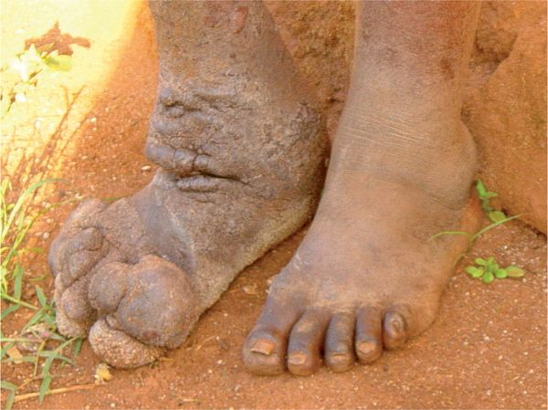

Return to the top
med-9780199204854-div1-090508010
Table 9.5.8.1 Criteria for distinguishing of podoconiosis from filarial elephantiasis
Characteristic | Podoconiosis | Filarial disease
Area of residence | >1500 m above sea level | <1000 m above sea level
Mean age of onset | 10–20 years | 25–30 years
Relation to natural history | Initial symptom | Late complication
Site of first symptom | Toes and foot | Any part of limb except foot
Local lymphadenitis | Follows swelling of limb | Precedes swelling of limb
Typical site of swelling | Distal, below knee | Above and below knee
Prognosis
The excess mortality associated with podoconiosis is unknown. Untreated patients have severely reduced mobility and work capacity by their mid-40s. Episodes of secondary infection cause additional disability.
Return to the top
med-9780199204854-div1-090508011
Economic burden and social stigma
Recent work has detailed the enormous economic burden of podoconiosis on affected communities. In a southern Ethiopian zone of 1.5 million inhabitants, where the prevalence of podoconiosis is known to be 5.4%, the overall cost of podoconiosis was estimated to be in excess of US$16 million per year. In this zone, where the average income is less than US$100 per year, the direct costs to a patient are US$143 per year.
Individuals with podoconiosis are highly stigmatized. They may be excluded from school, rejected by their family, barred from social and religious gatherings, and banned from marriage to any unaffected individual. Siblings of affected individuals are also frequently barred from marriage into unaffected families.
Return to the top
med-9780199204854-div1-090508012
Global awareness
Podoconiosis was included on the WHO list of Neglected Tropical Diseases (NTDs) in February 2011. Subsequently, an Ethiopian network, the National Podoconiosis Action Network (NaPAN) and a global initiative, Footwork, the International Podoconiosis Initiative (www.podo.org) have been developed. These aim to lobby for and co-ordinate integration of podoconiosis interventions into NTD control strategies at national and international levels.

Likely developments
The precise nature of the interaction between host and irritant particles is still unclear. Studies of the genetic basis of podoconiosis continue. Studies examining host immunological and inflammatory responses would be valuable. Adaptation of a clinical scoring system similar to that developed for filarial elephantiasis will permit more accurate staging and assessment of interventions. A pilot study of distribution of footwear to children of affected households is under way.
Further reading
Return to the top
med-9780199204854-bibList-090508001
Davey G, Newport M (2007). Podoconiosis: the most neglected tropical disease? Lancet, 369, 888–9.
Price EW (1990). Podoconiosis: non-filarial elephantiasis. Oxford Medical Publications, Oxford.
Tekola F, et al. (2006). Economic costs of podoconiosis (endemic non-filarial elephantiasis) in Wolaita Zone, Ethiopia. Trop Med Int Health, 11,1136–44.
Tekola Ayele F, et al. (2012). The HLA Class II Locus Confers Susceptibility to Podoconiosis. N Engl J Med, 388,1200-1208.
Yakob B, et al. (2008). High levels of misconceptions and stigma in a community highly endemic for podoconiosis in southern Ethiopia. Trans R Soc Trop Med Hyg, 102(5), 439–44.

